**R2R Flow**

**Steps to be followed:**

1. **Enter invoice in Accounts Payables**
2. **Create Mass Additions from Payables**
3. **Prepare Mass Additions**
4. **Post Mass Additions**
5. **Create Accounting**
6. **Find Asset**
7. **Journal Entries GL**

**Login as: FAS01.Student**

**Step 1: Enter invoice in Accounts Payables**

**Navigate to Payables 🡪 Invoices.**

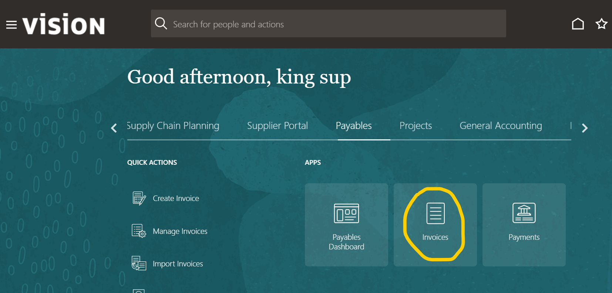

**Click on Create Invoice**

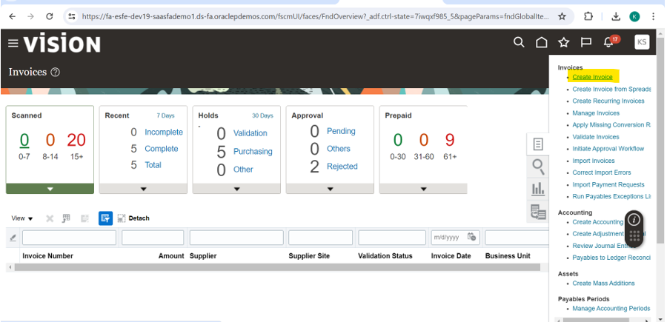

**Enter Supplier details and Mandatory Columns as shown in below screenshot.**

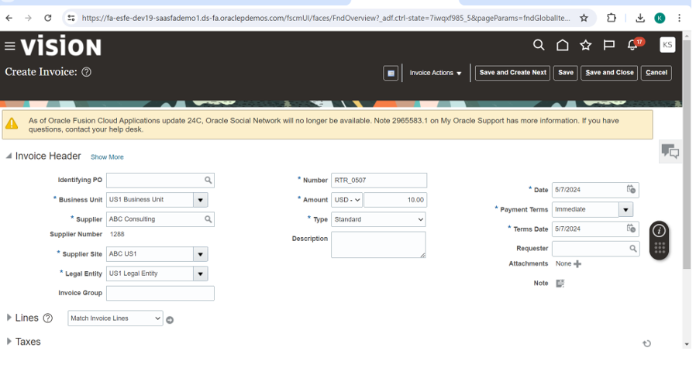**Expand the lines. Enter line details. Enable the check box Track as Asset.**

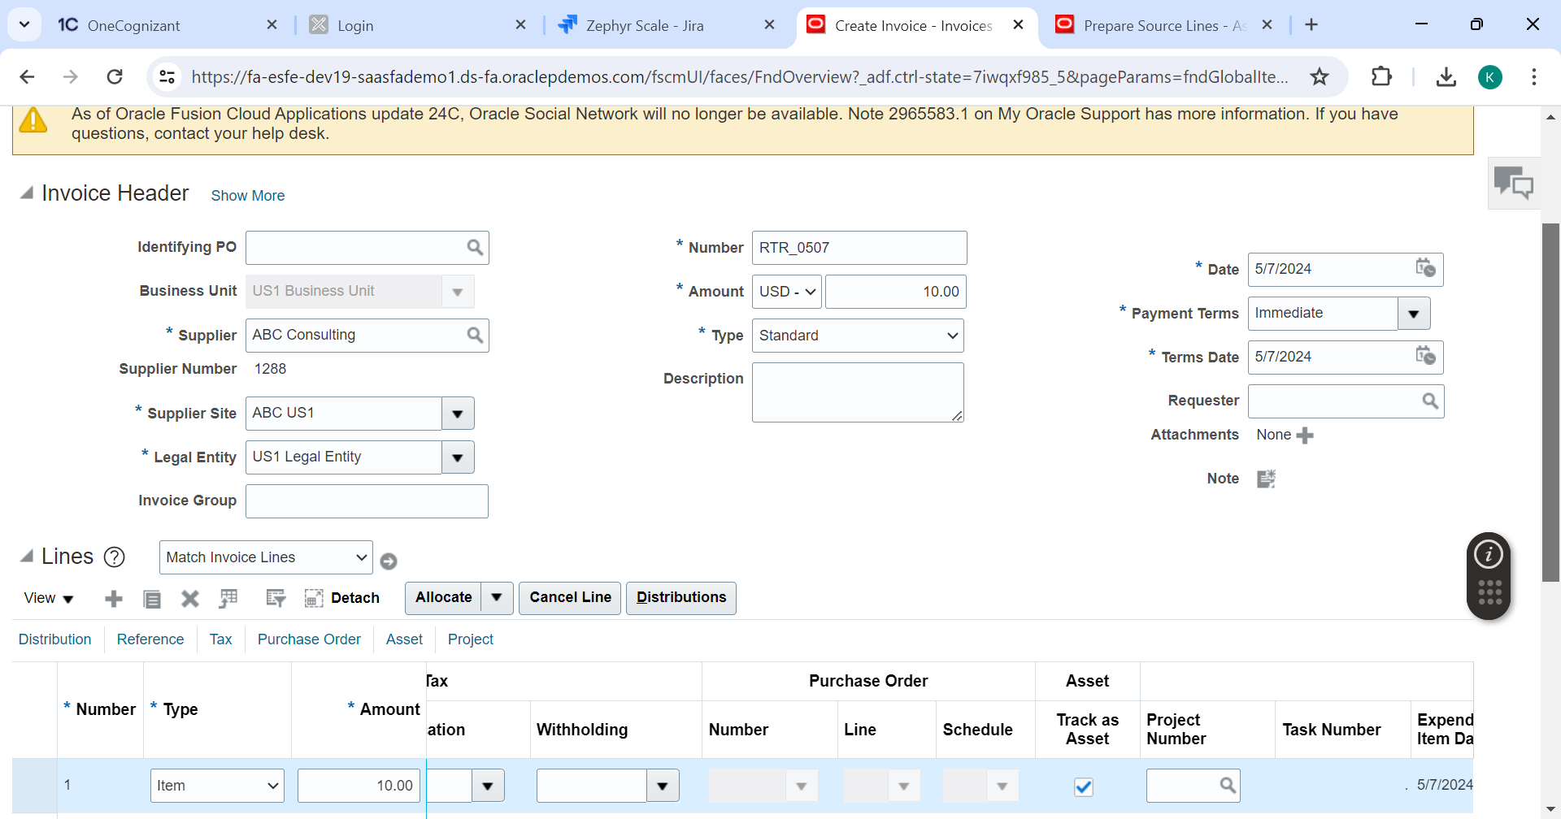

**Note: Make sure the Distribution set is asset clearing account.**

**Click on Save**

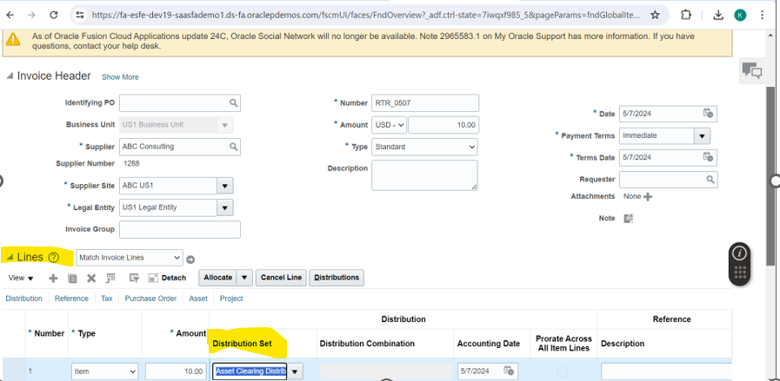

**From Invoice Actions drop down Click on validate**

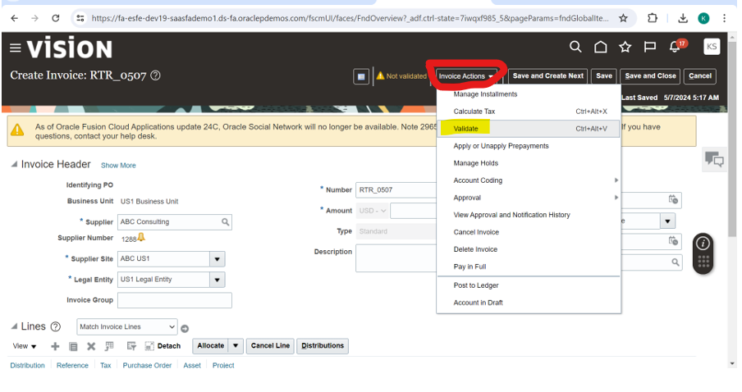

**Invoice Validated.**

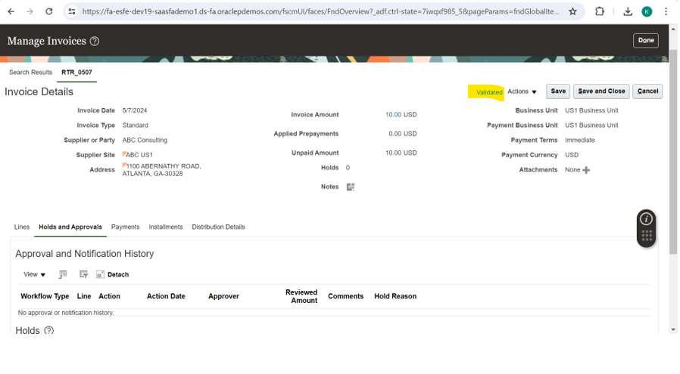

**Click on Actions 🡪 Post to Ledger**

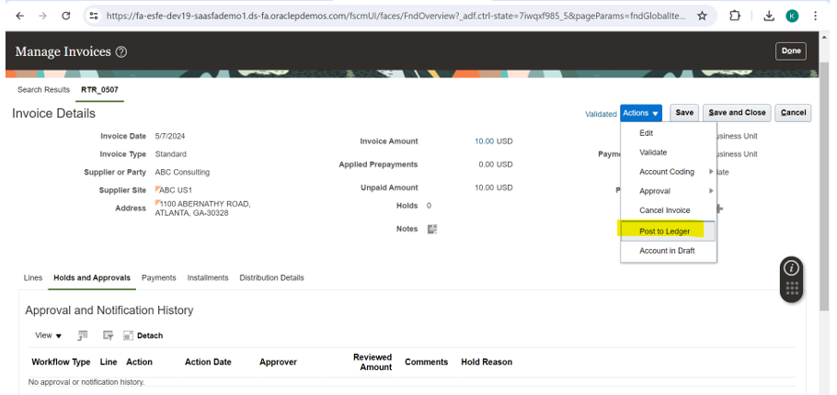

**Accounting completed Successfully.**

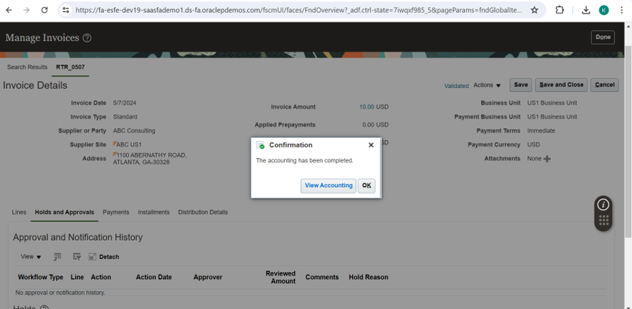

**Click on View Accounting**

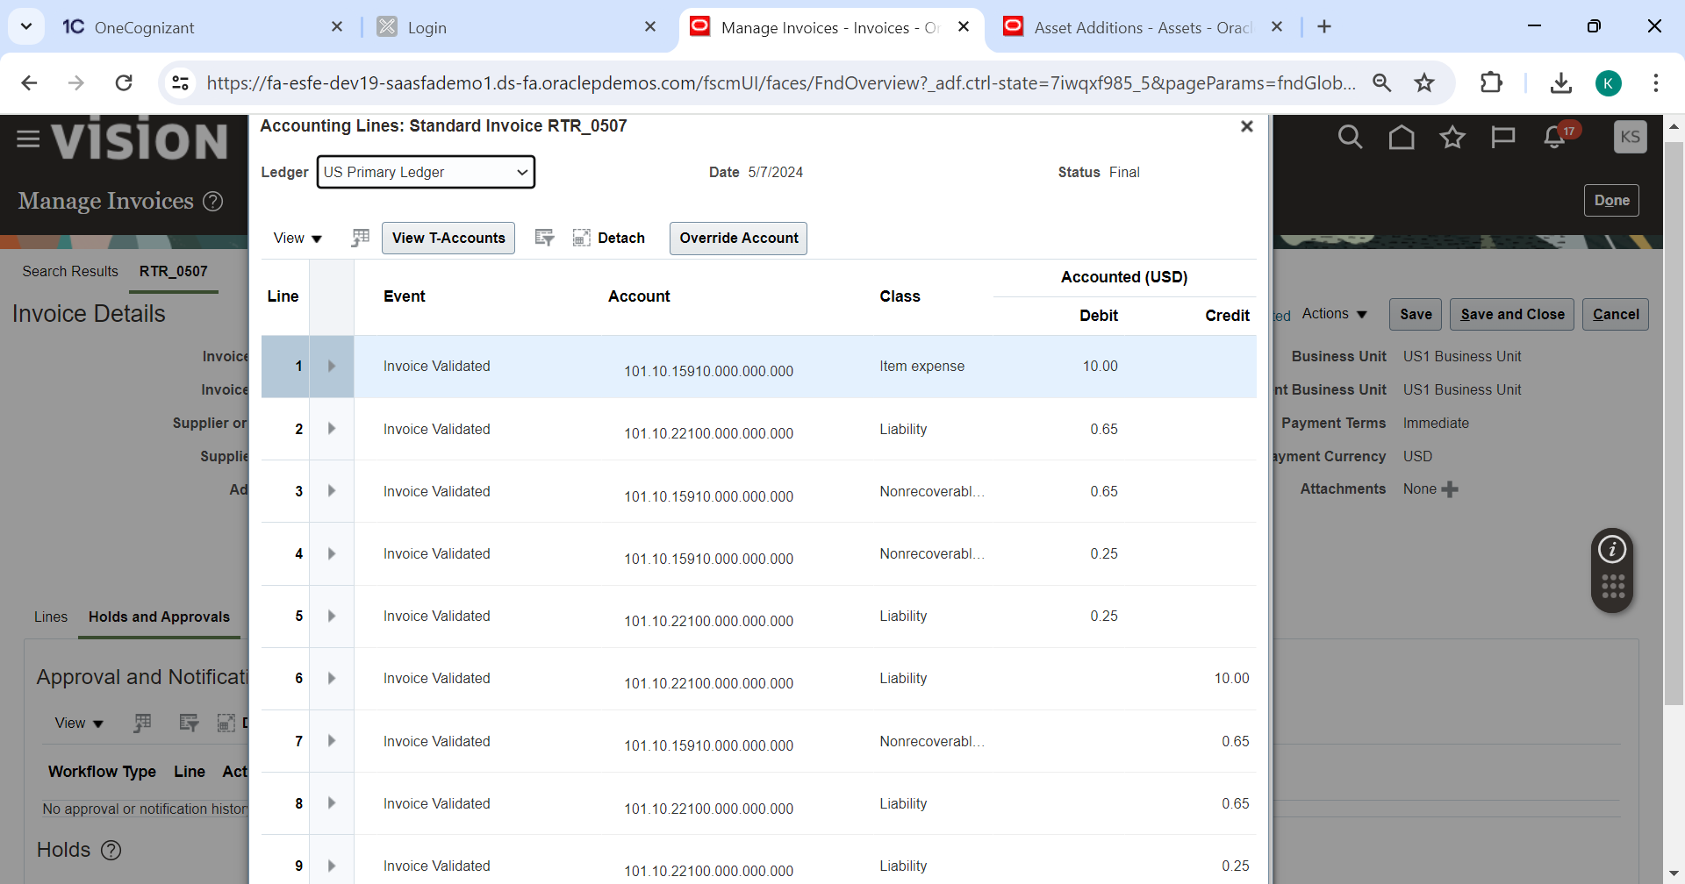

**Step 2: Create Mass Additions from Payables**

**Go to Task panel from Invoices 🡪Create Mass Additions**

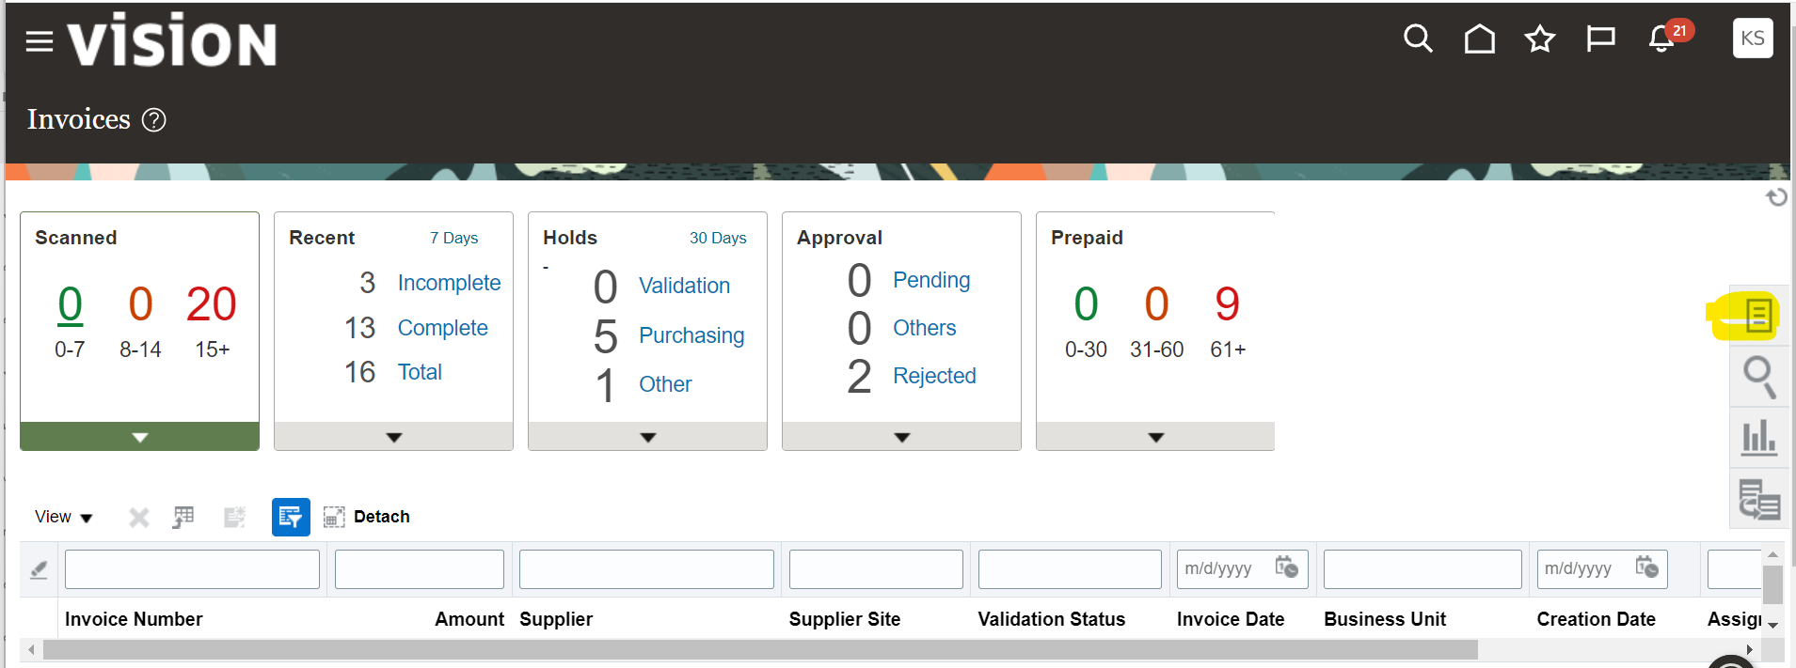

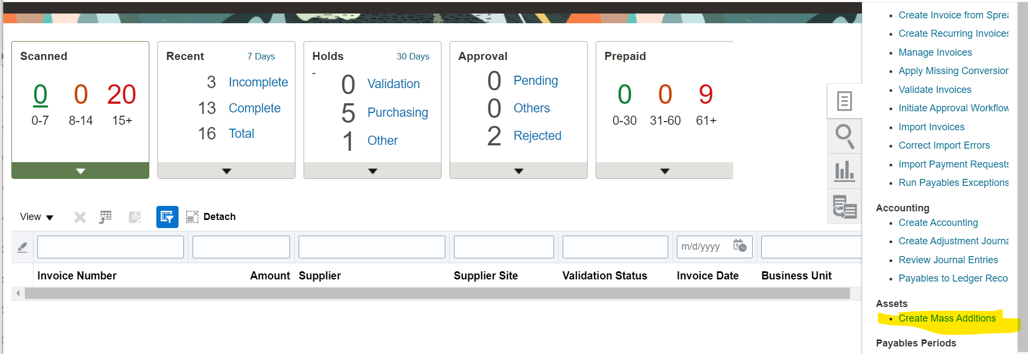

**Enter the accounting date and Asset book and click on submit.**

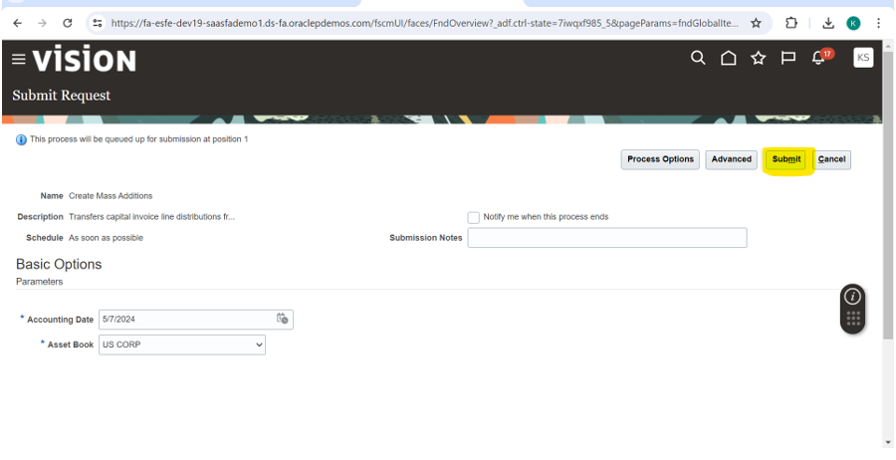

**Process submitted successfully.**

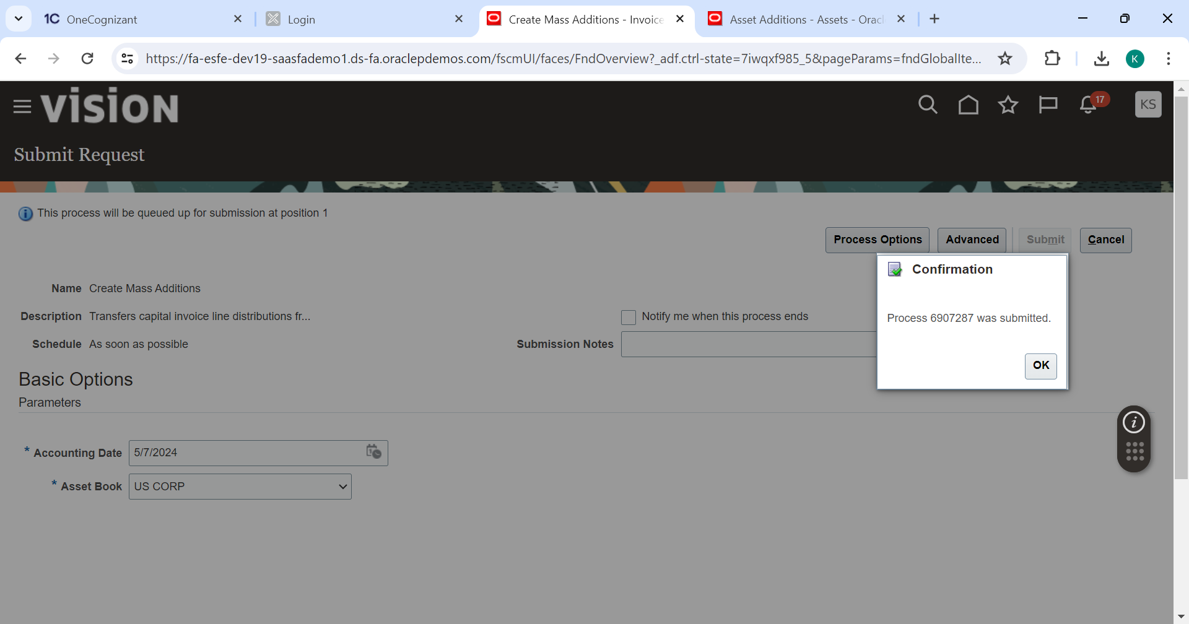

**Navigate to 🡪Tools🡪 Scheduled process. Create Mass addition report is successfully completed.**

**Click on the report.**

**Click on Republish**

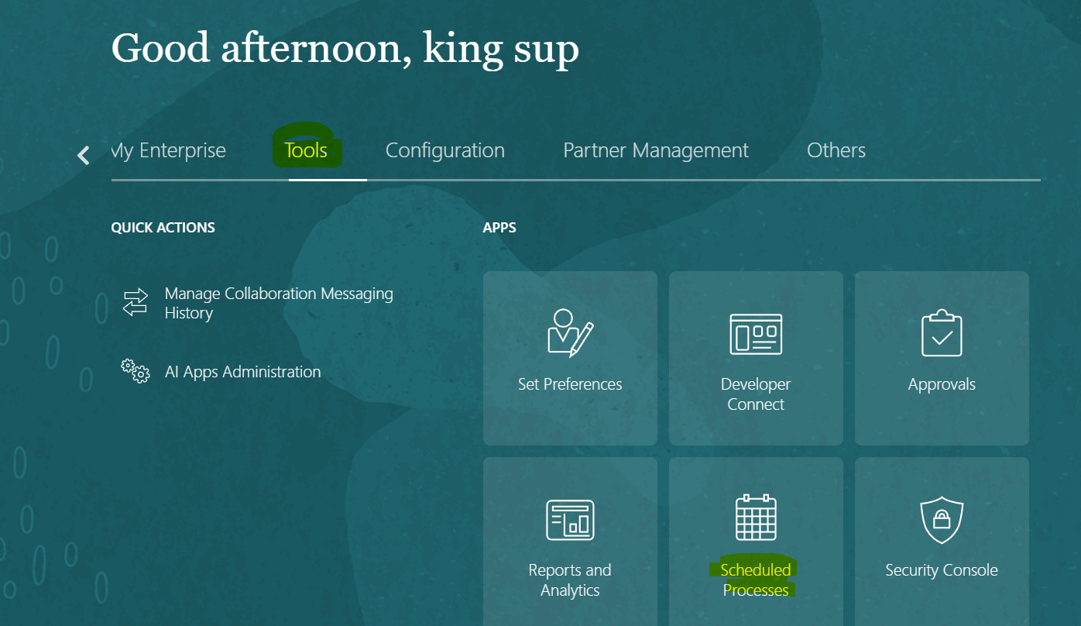

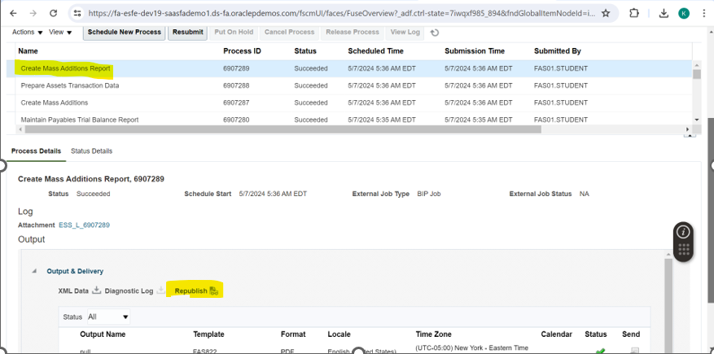

**Click on Export 🡪PDF. Report will be downloaded.**

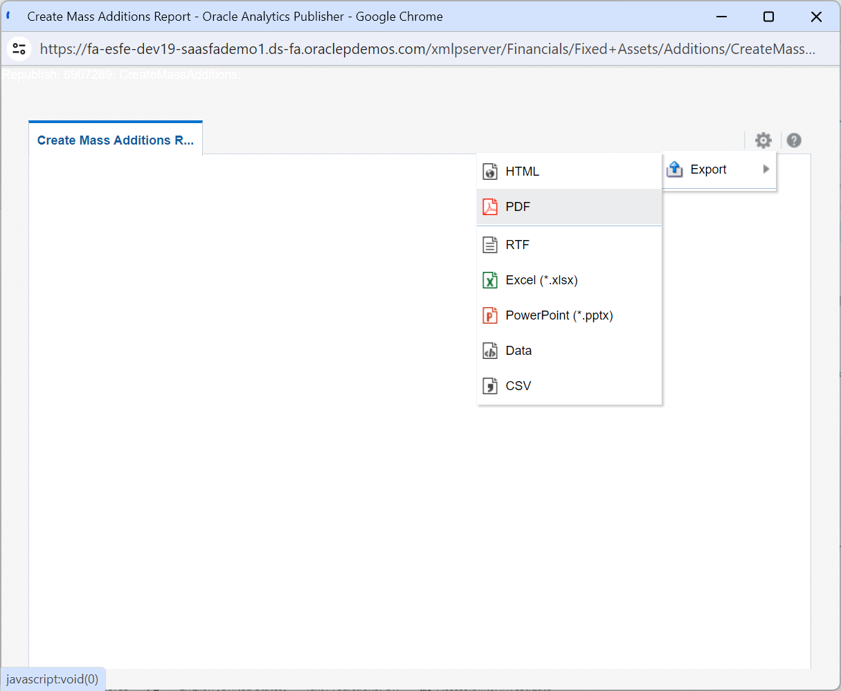

**From downloads, open the report. Mass additions created successfully for the invoice.**

**We can see the Invoice number in report output.**

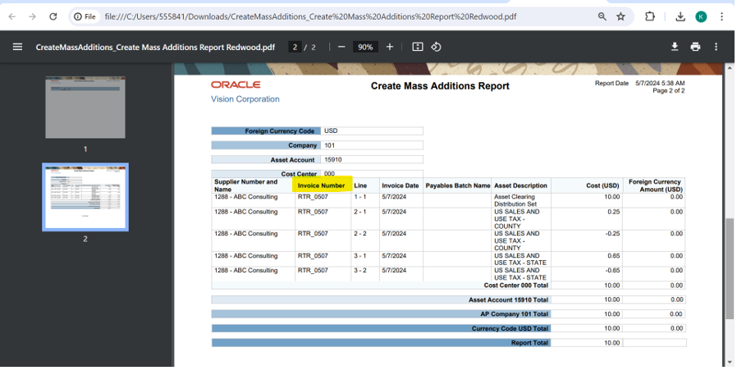

**Step 3: Prepare Mass Additions**

**Navigate to Fixed Assets from Home Page**

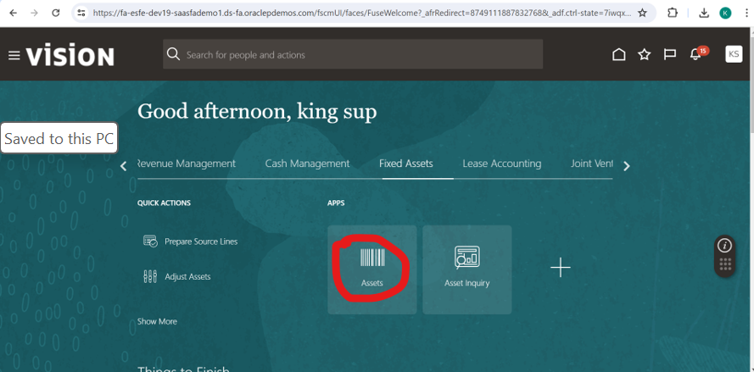

**Click on Prepare Source lines.**

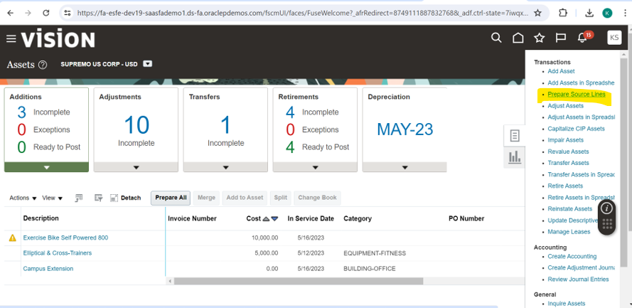

**Enter the Book and Invoice number which we got in Mass addition report as shown below and search.**

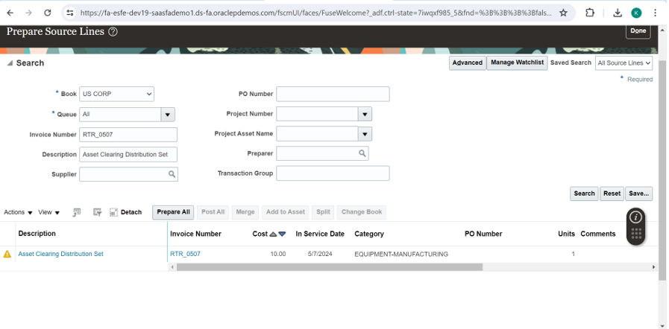**Update location detail by clicking on search option.**

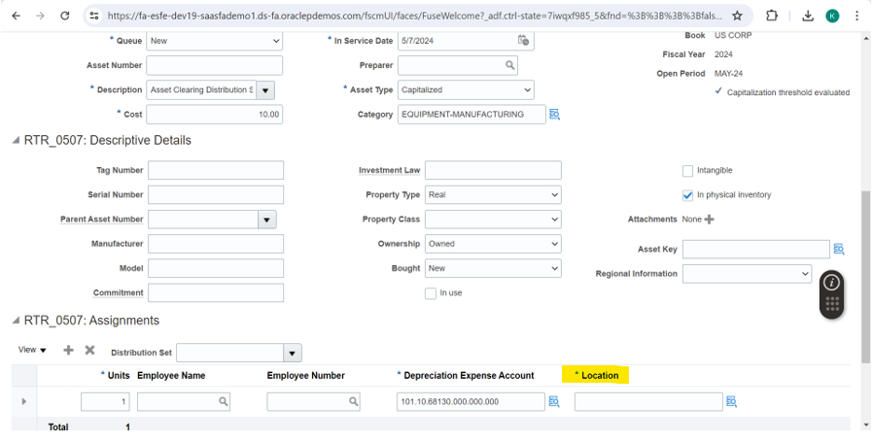

**Choose the Location details as below.**

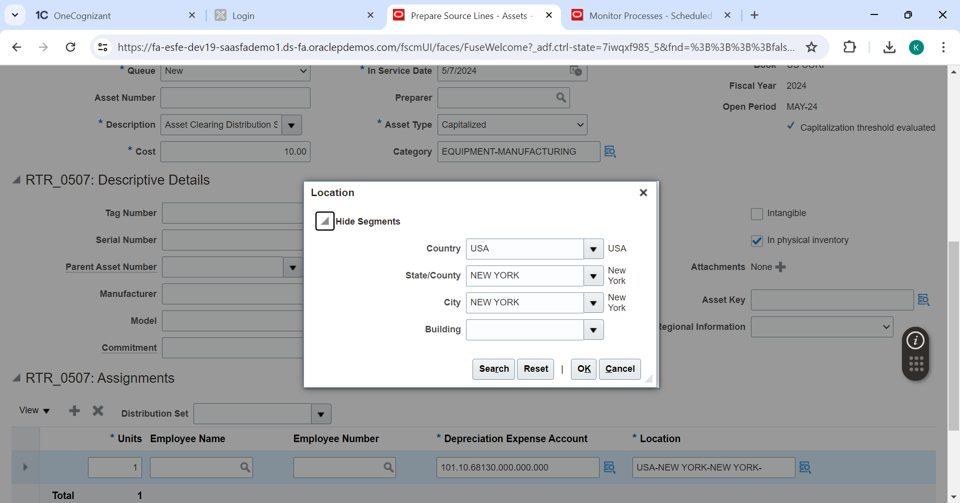

**Location details are entered.**

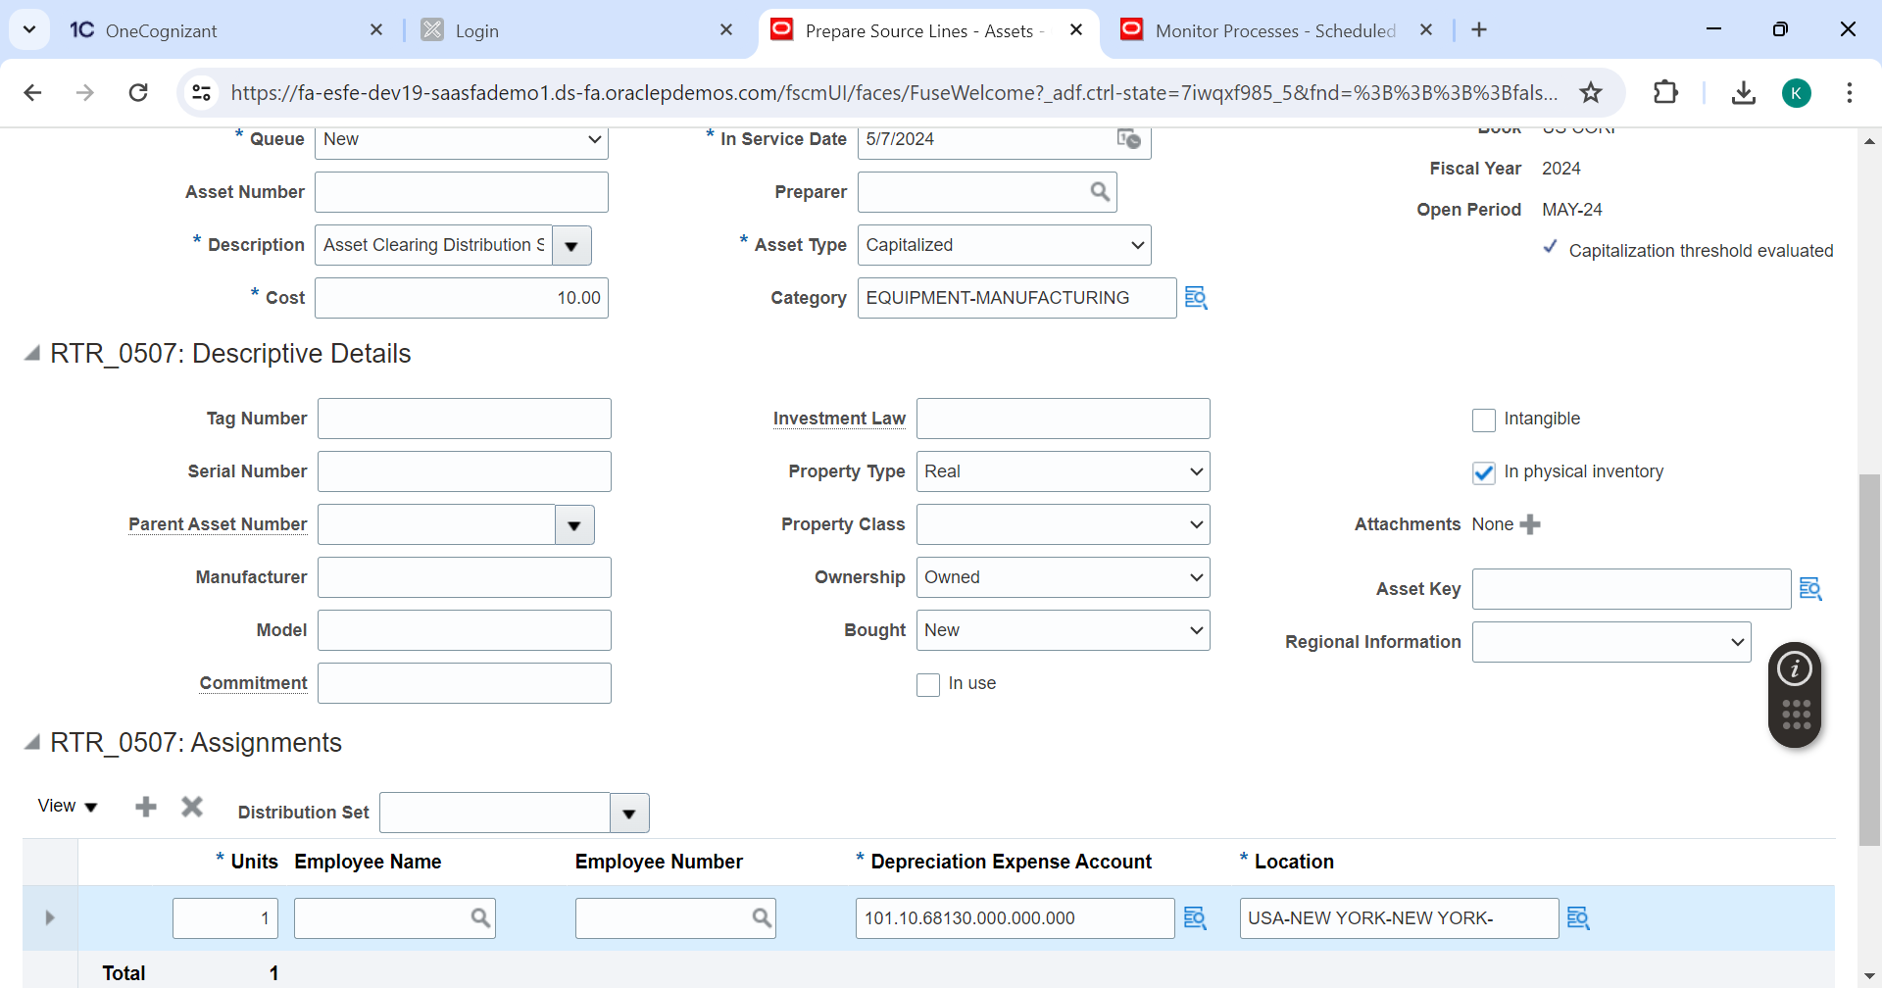

**Click on Save**

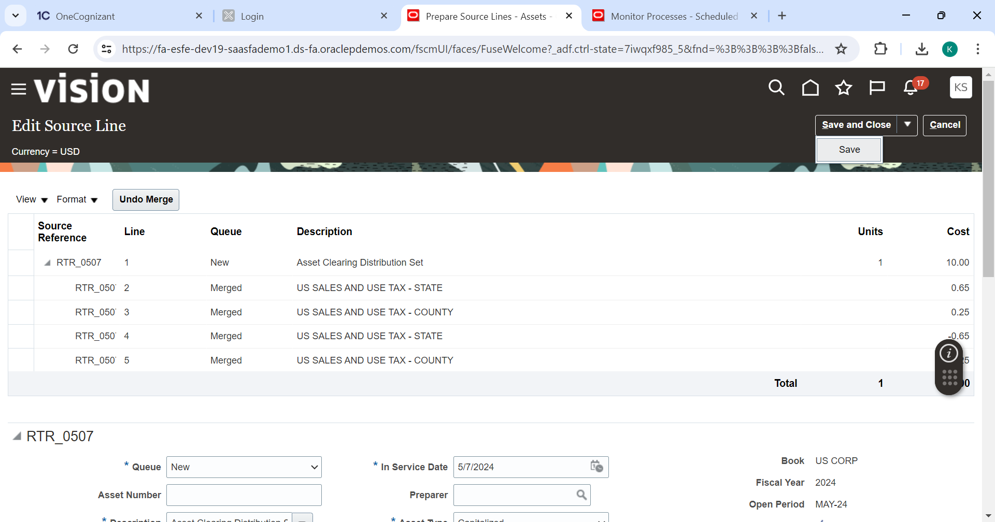

**Change the queue status to Post and Click Save & Close**

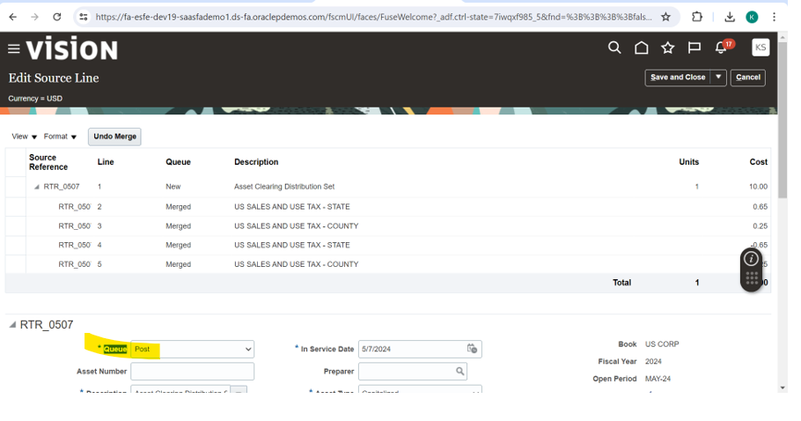

**Step 4: Post Mass Additions**

**Select the line and click post all.**

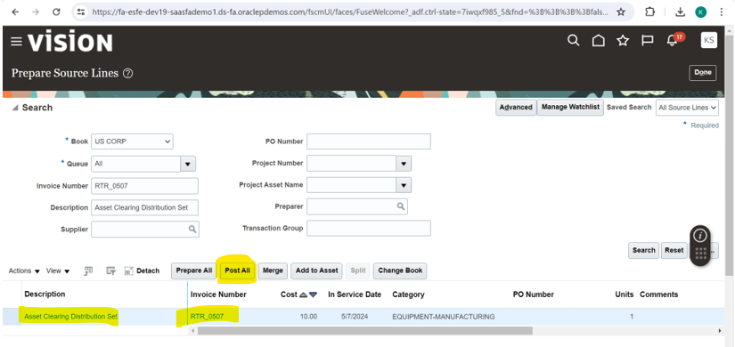

**Asset Addition submitted successfully.**

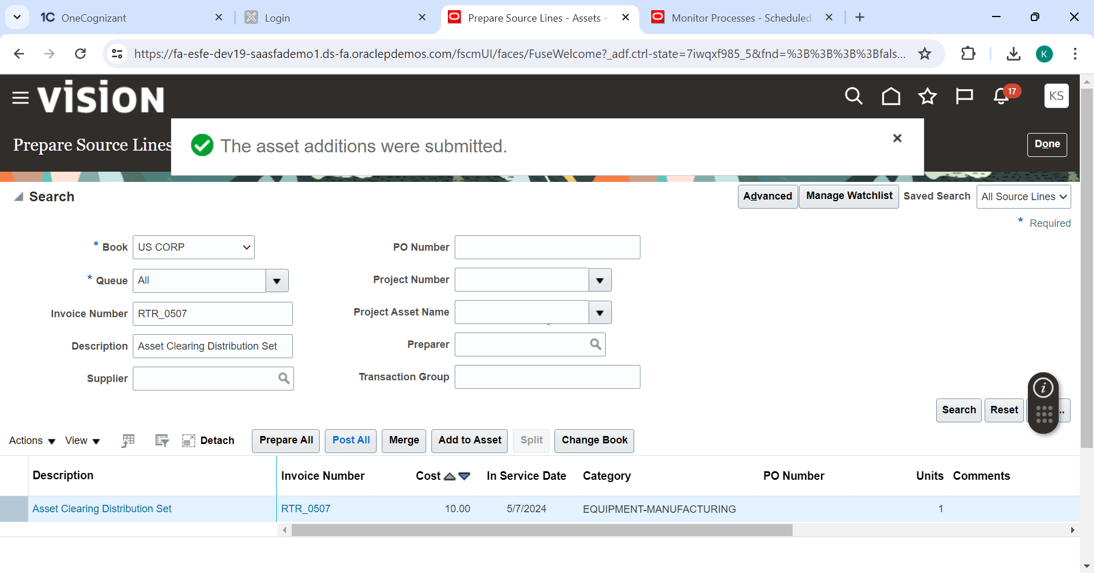

**Navigate to Tools > Scheduled Process and Search for Post Mass Additions Report**

**Click on the report and republish.**

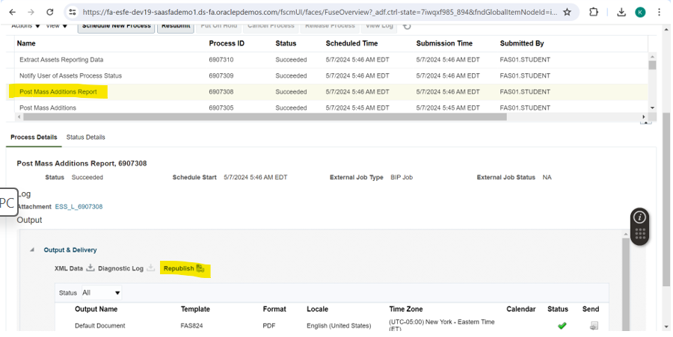

**Click on Export 🡪PDF.**

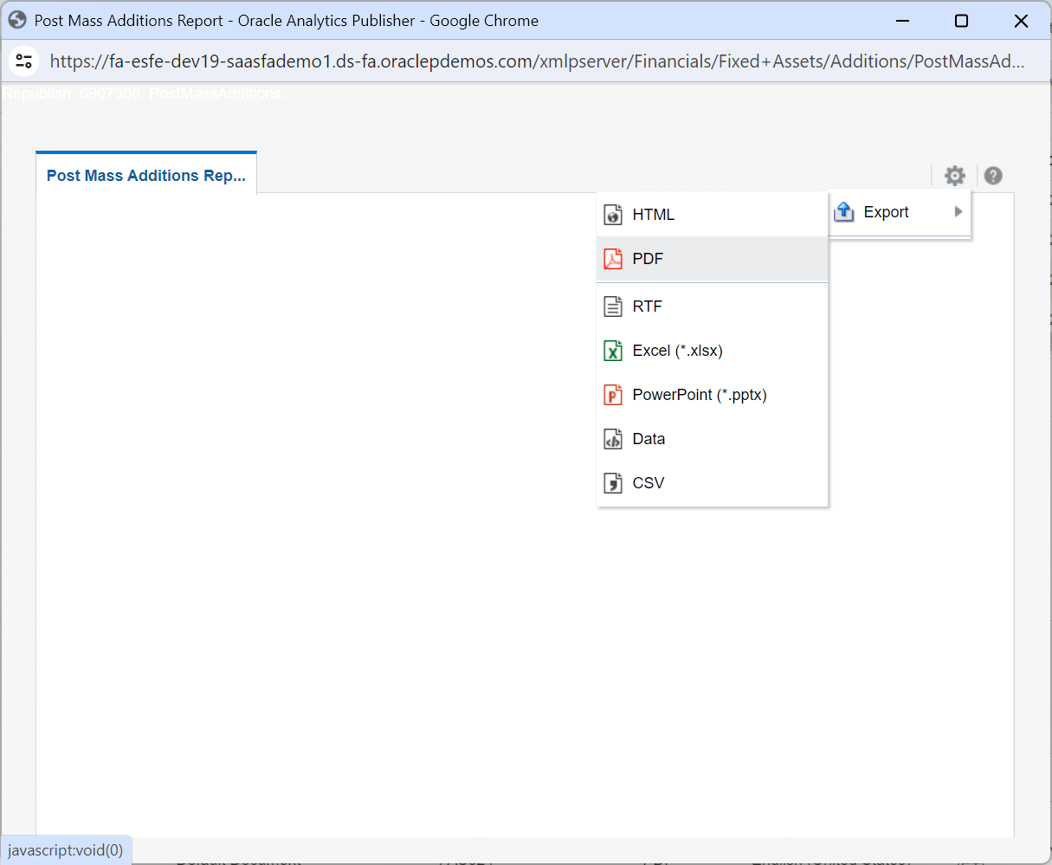

**From download view the report. Asset number is generated. Note it down.**

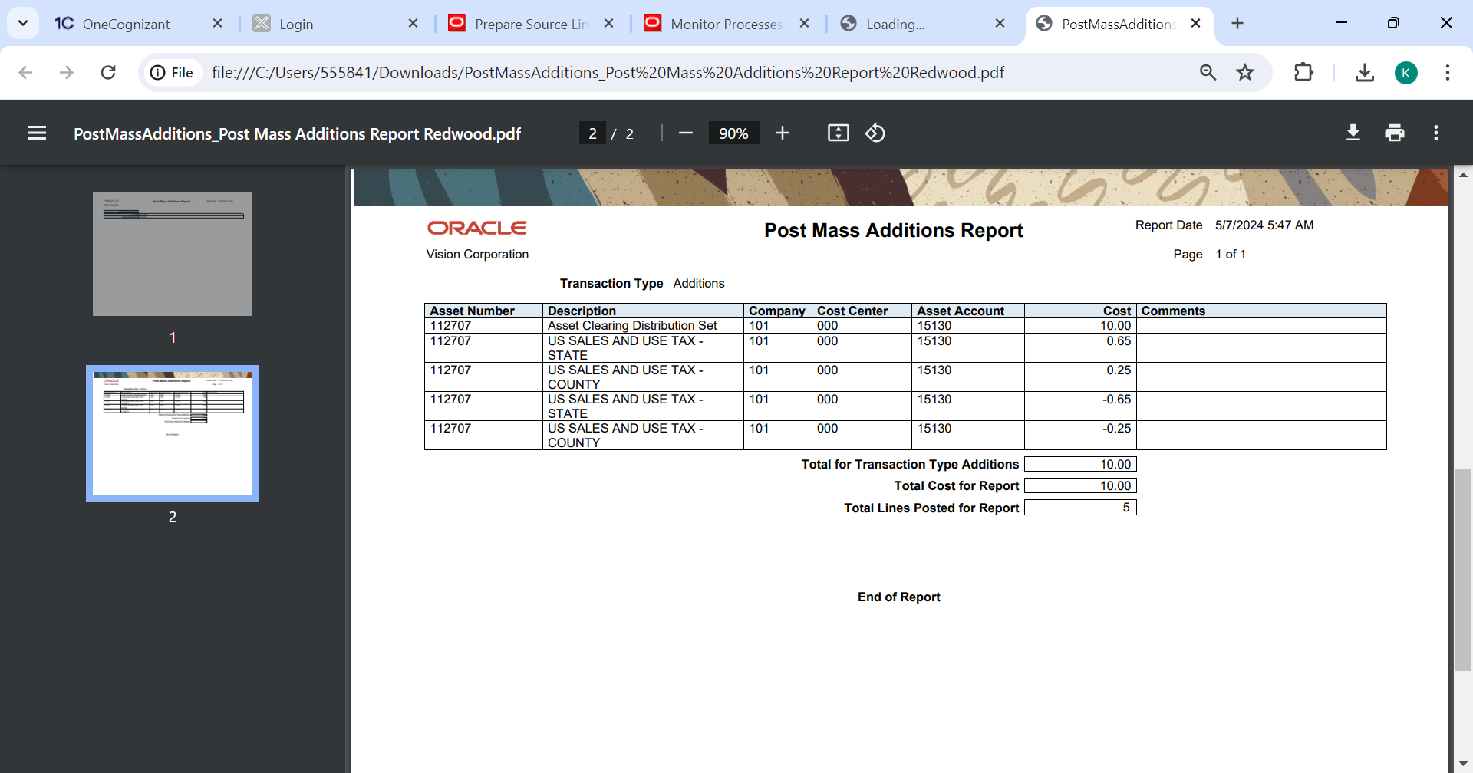

**Step 5: Create Accounting**

**Navigate to fixed assets 🡪Assets 🡪Create Accounting**

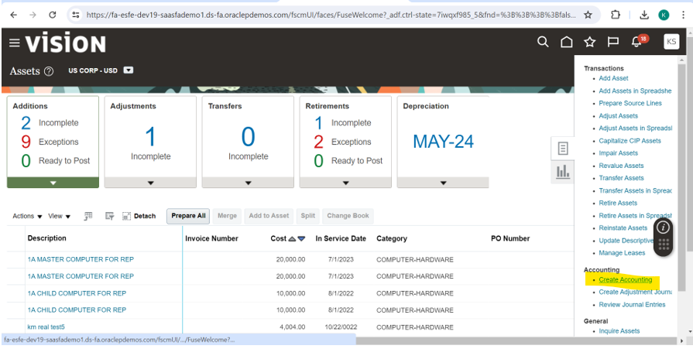

**Enter the details and submit the process as shown below.**

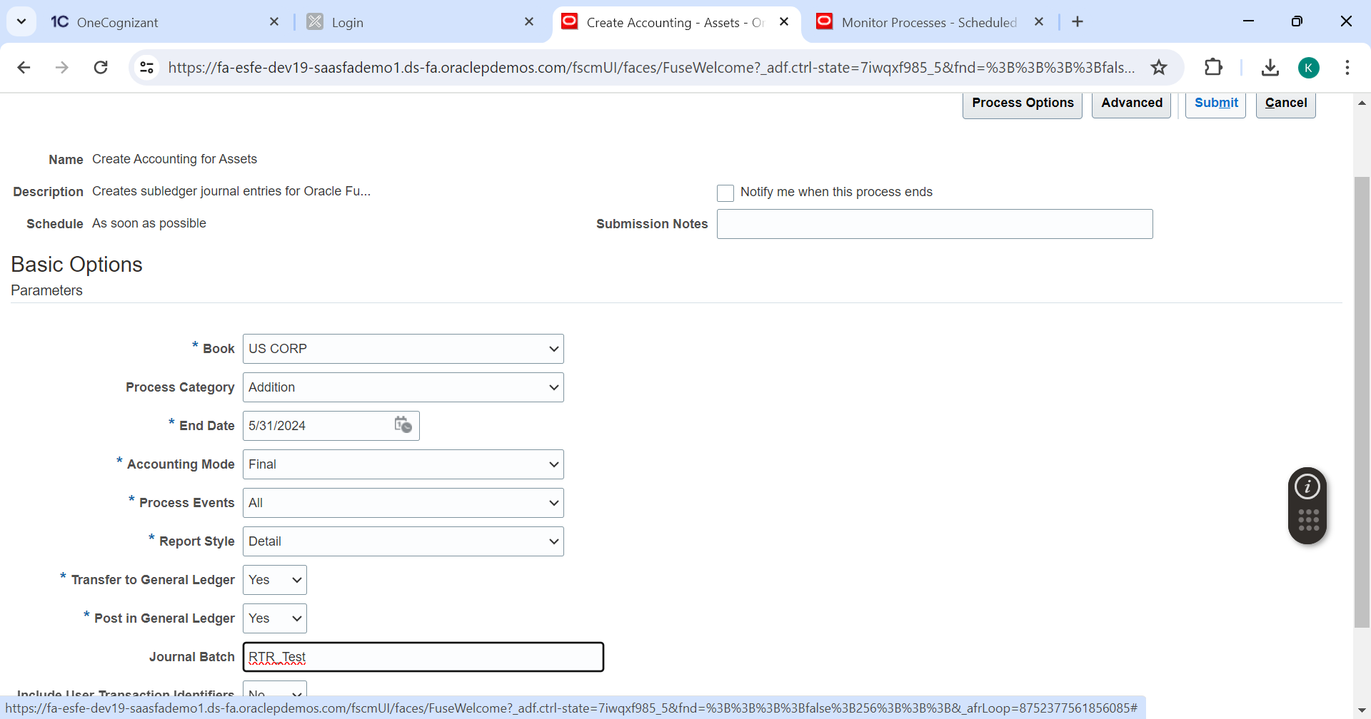

**Process Submitted successfully.**

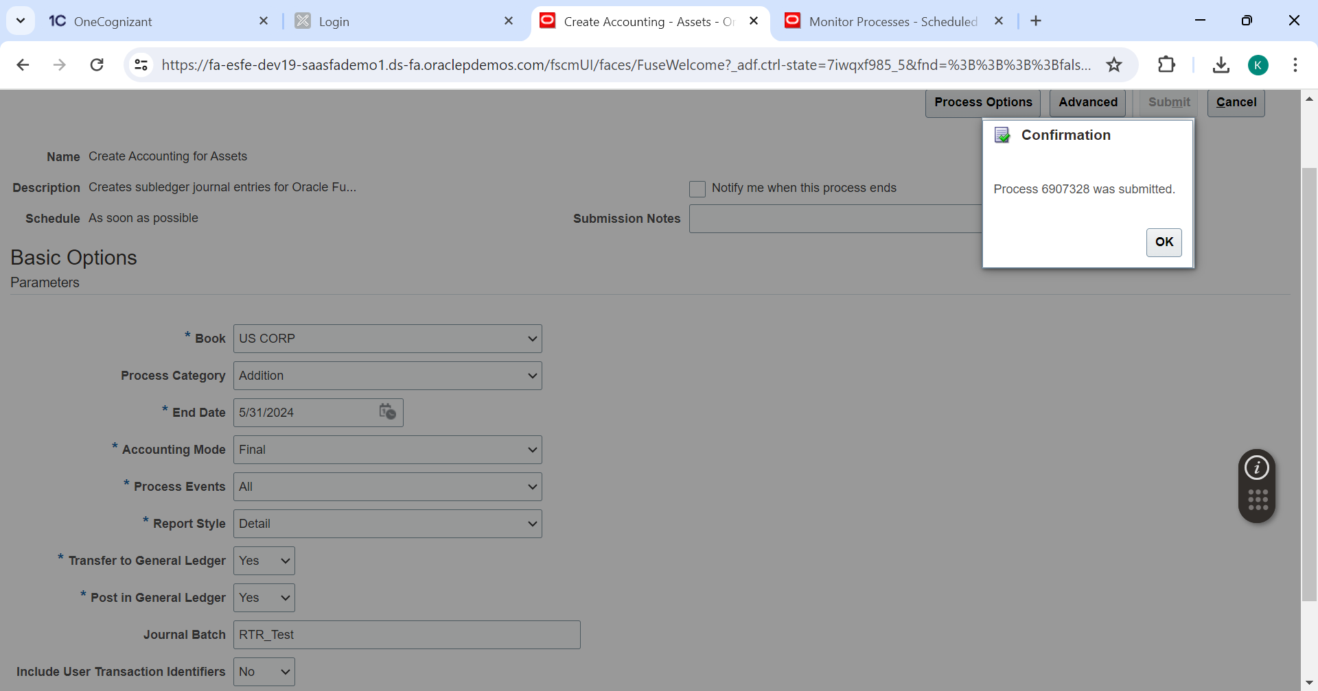

**Wait for Create Accounting Execution Report to get completed. Click on report once successfully and republish.**

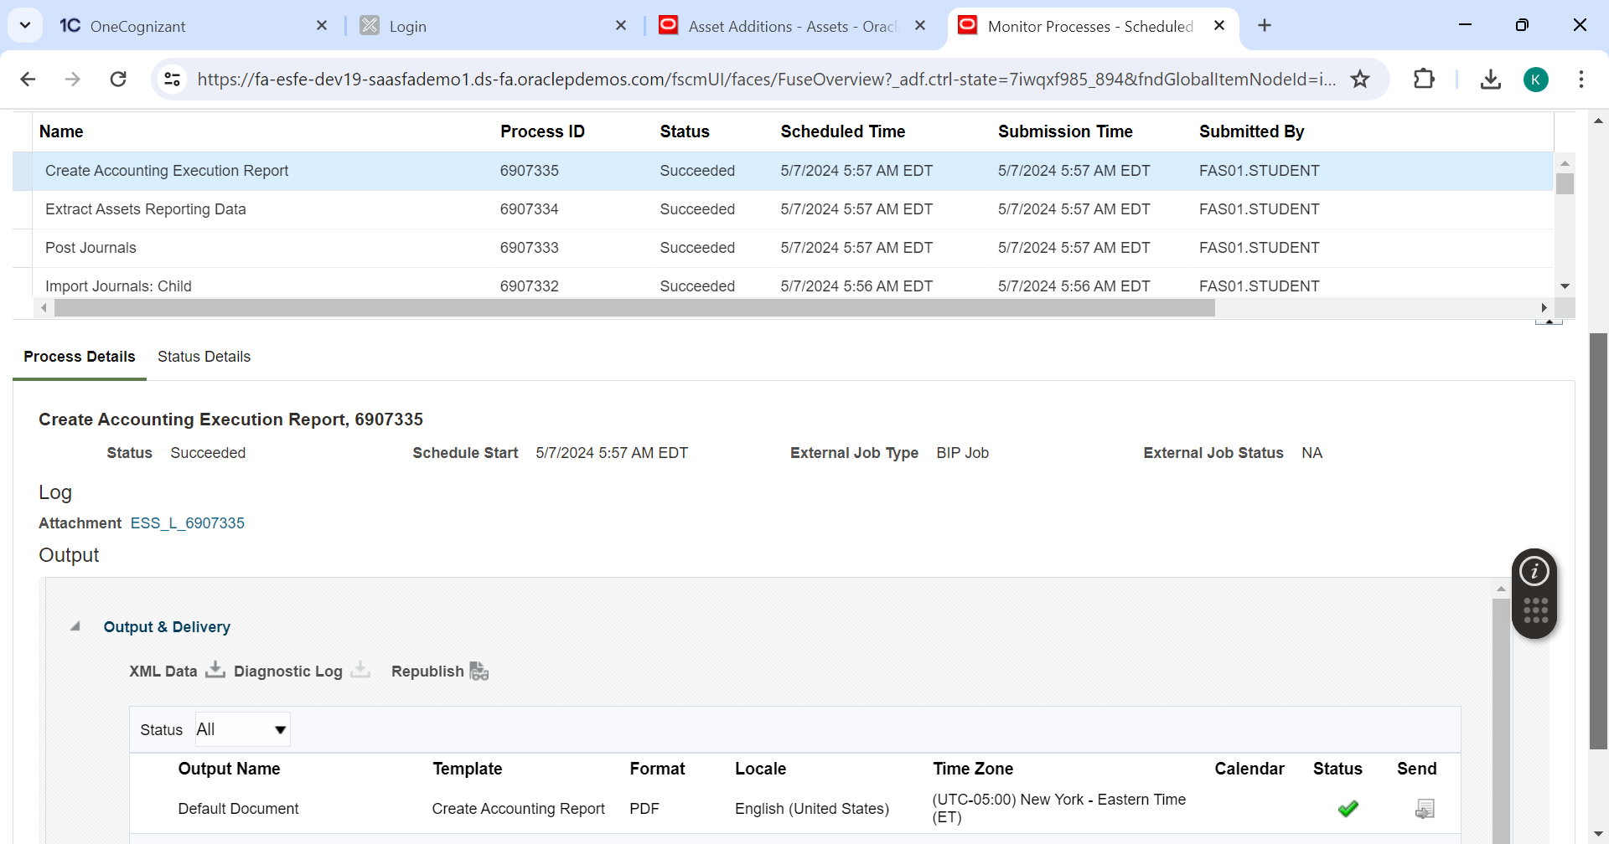

**Click on export 🡪PDF**

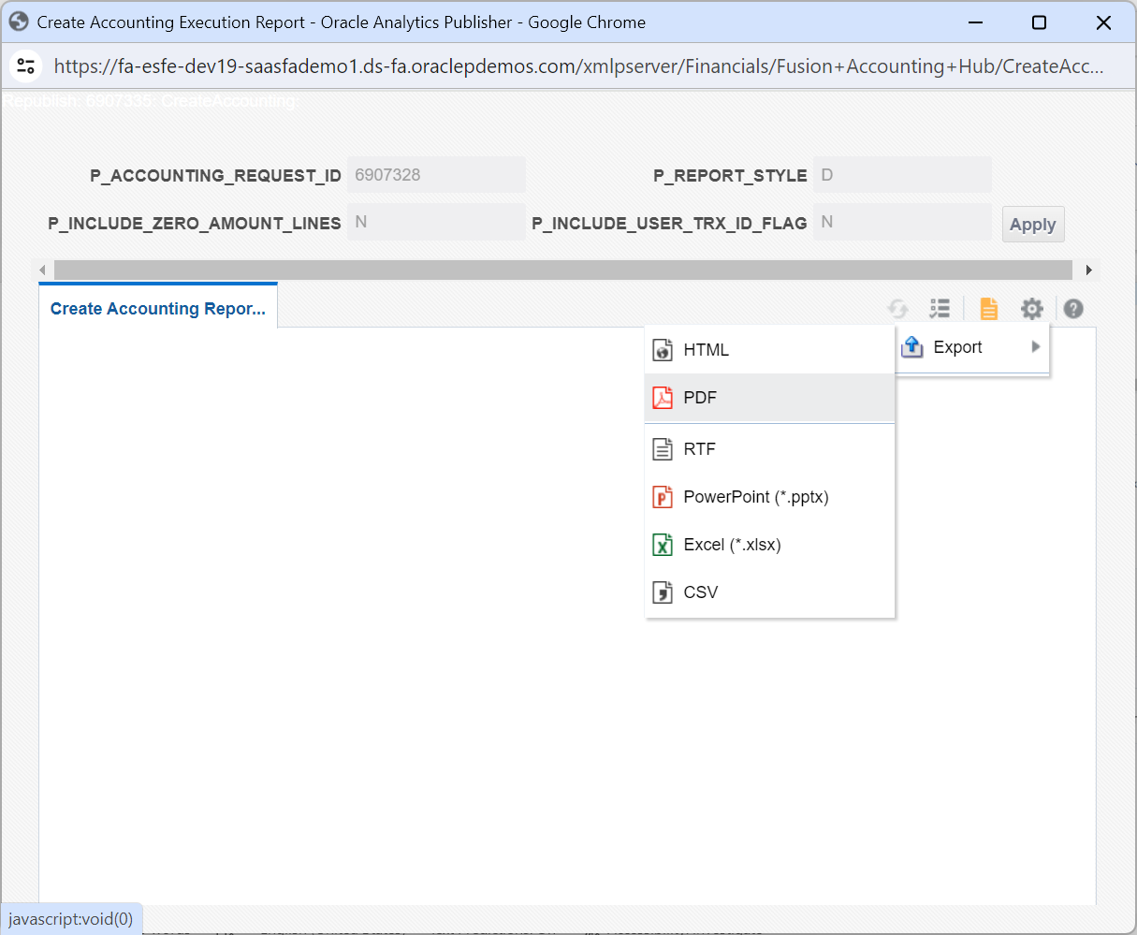

**View the report downloaded.**

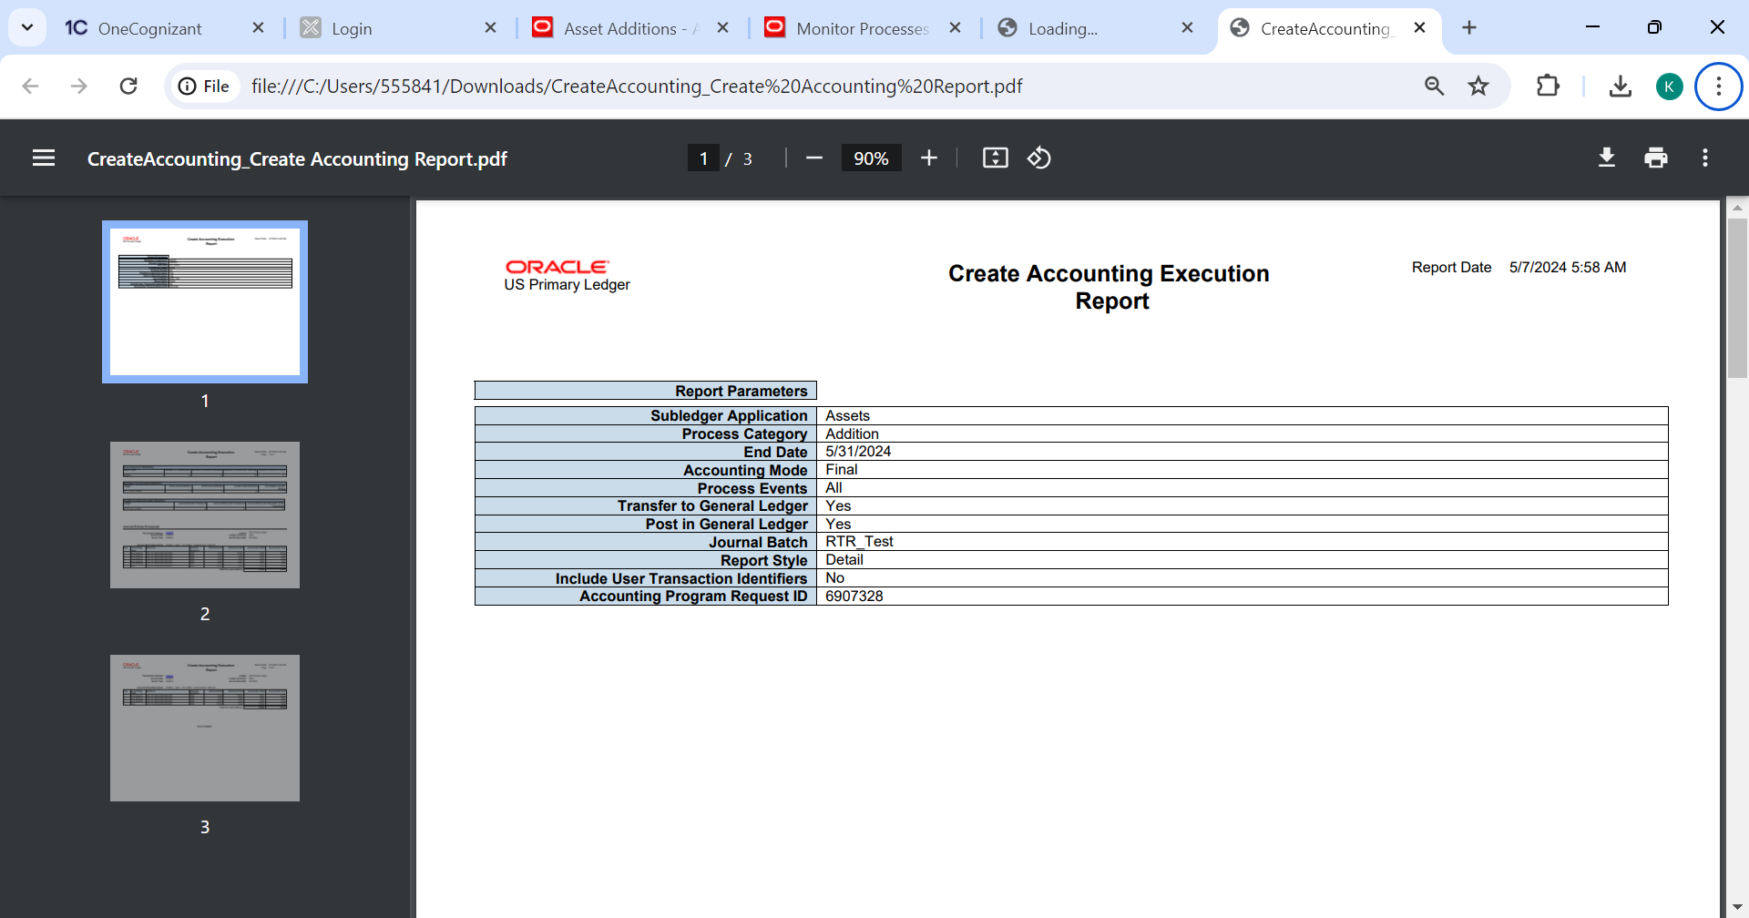

**Accounting details are generated.**

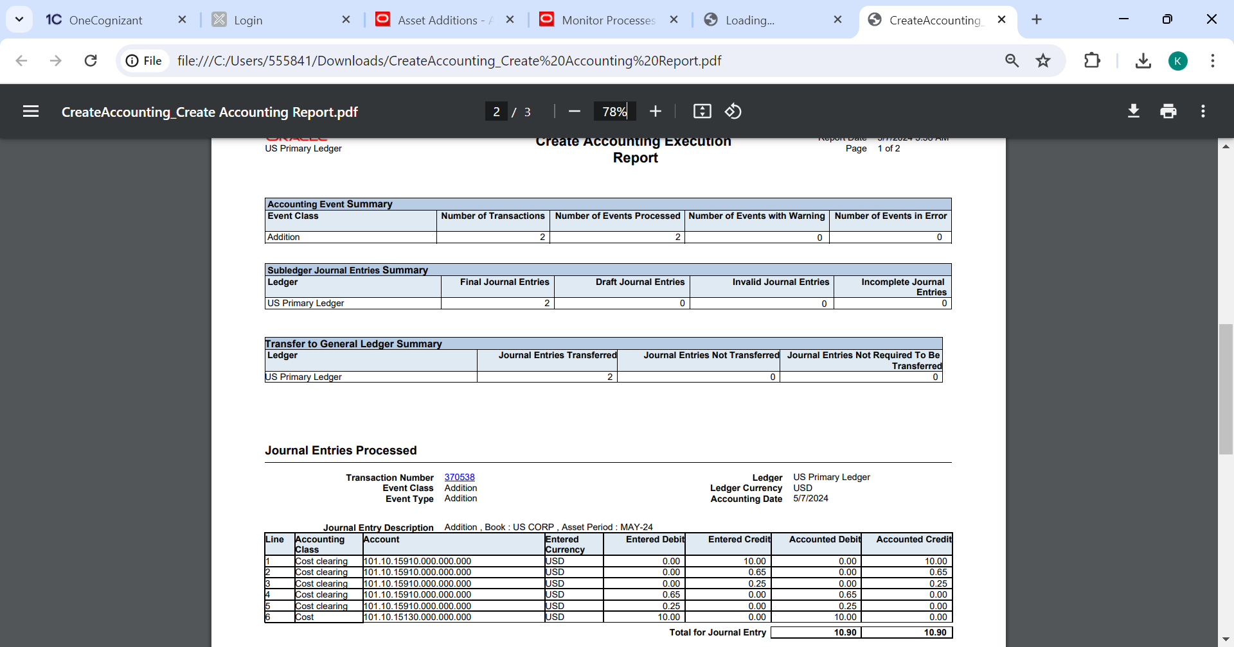



**Enter the details and submit the process as shown below.**



**Process Submitted successfully.**



**Wait for Create Accounting Execution Report to get completed. Click on report once successfully and republish.**



**Click on export 🡪PDF**



**View the report downloaded.**



**Accounting details are generated.**



**Step 6: Find Asset**

**Navigate Fixed Assets🡪 Asset Inquire**

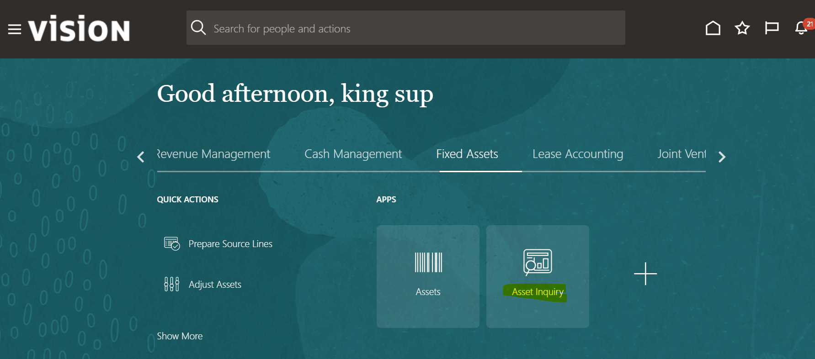

**Search for the Asset Number with Correct Asset book and click on search.**

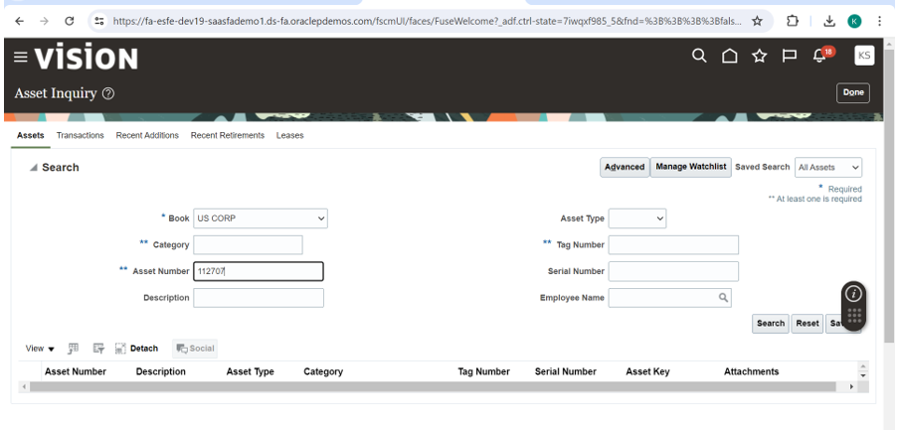

**Go to Transaction and click on the addition line.**

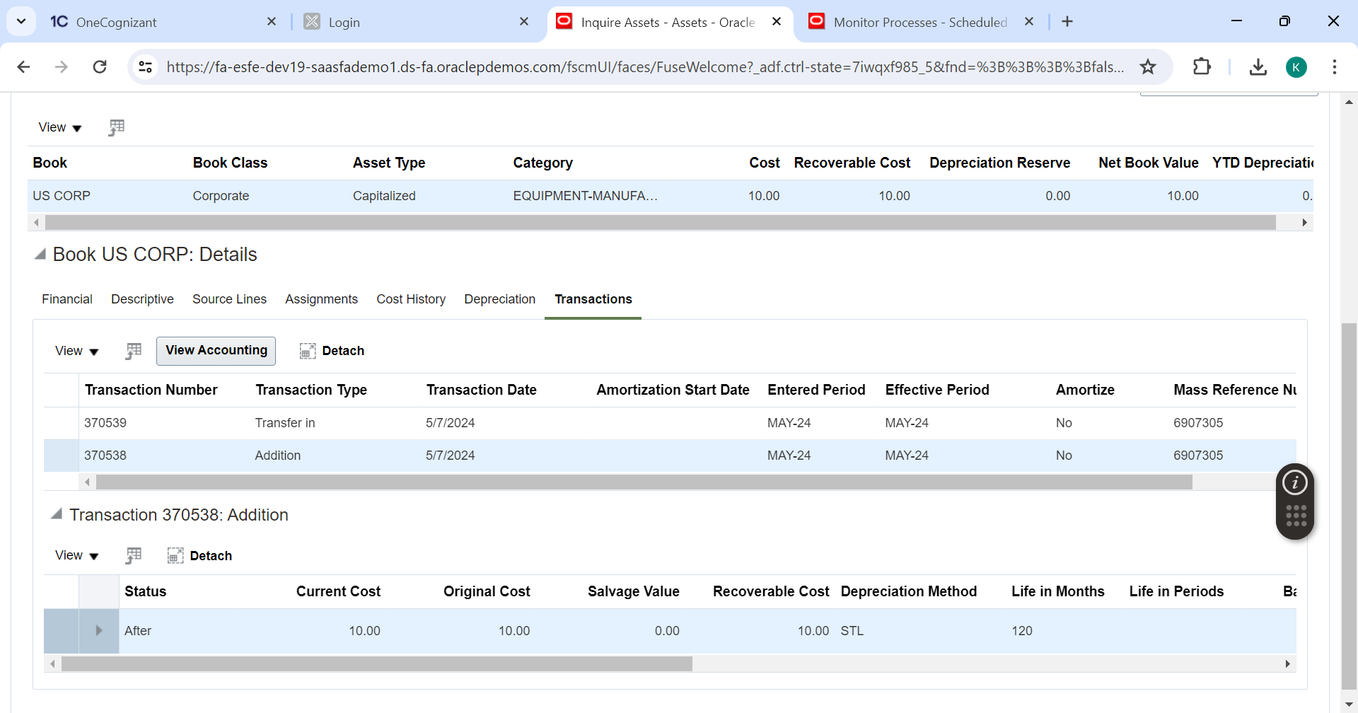

**Click on View Accounting**

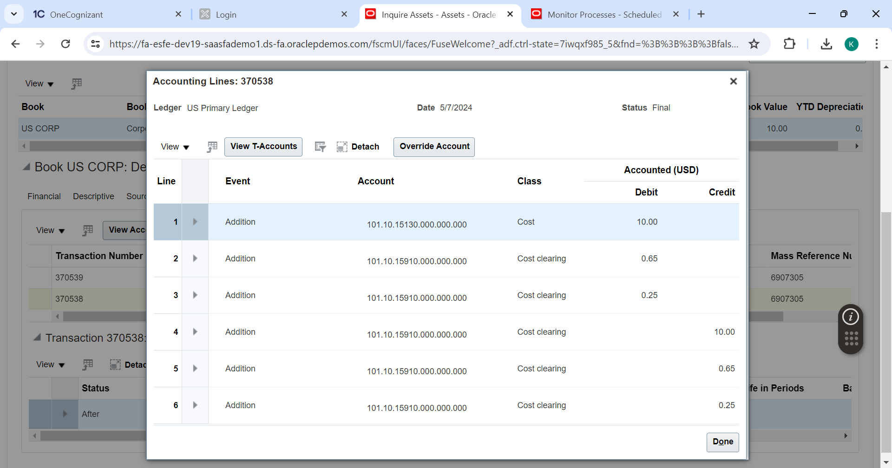

**Click on the first line 🡪Addition Addition**

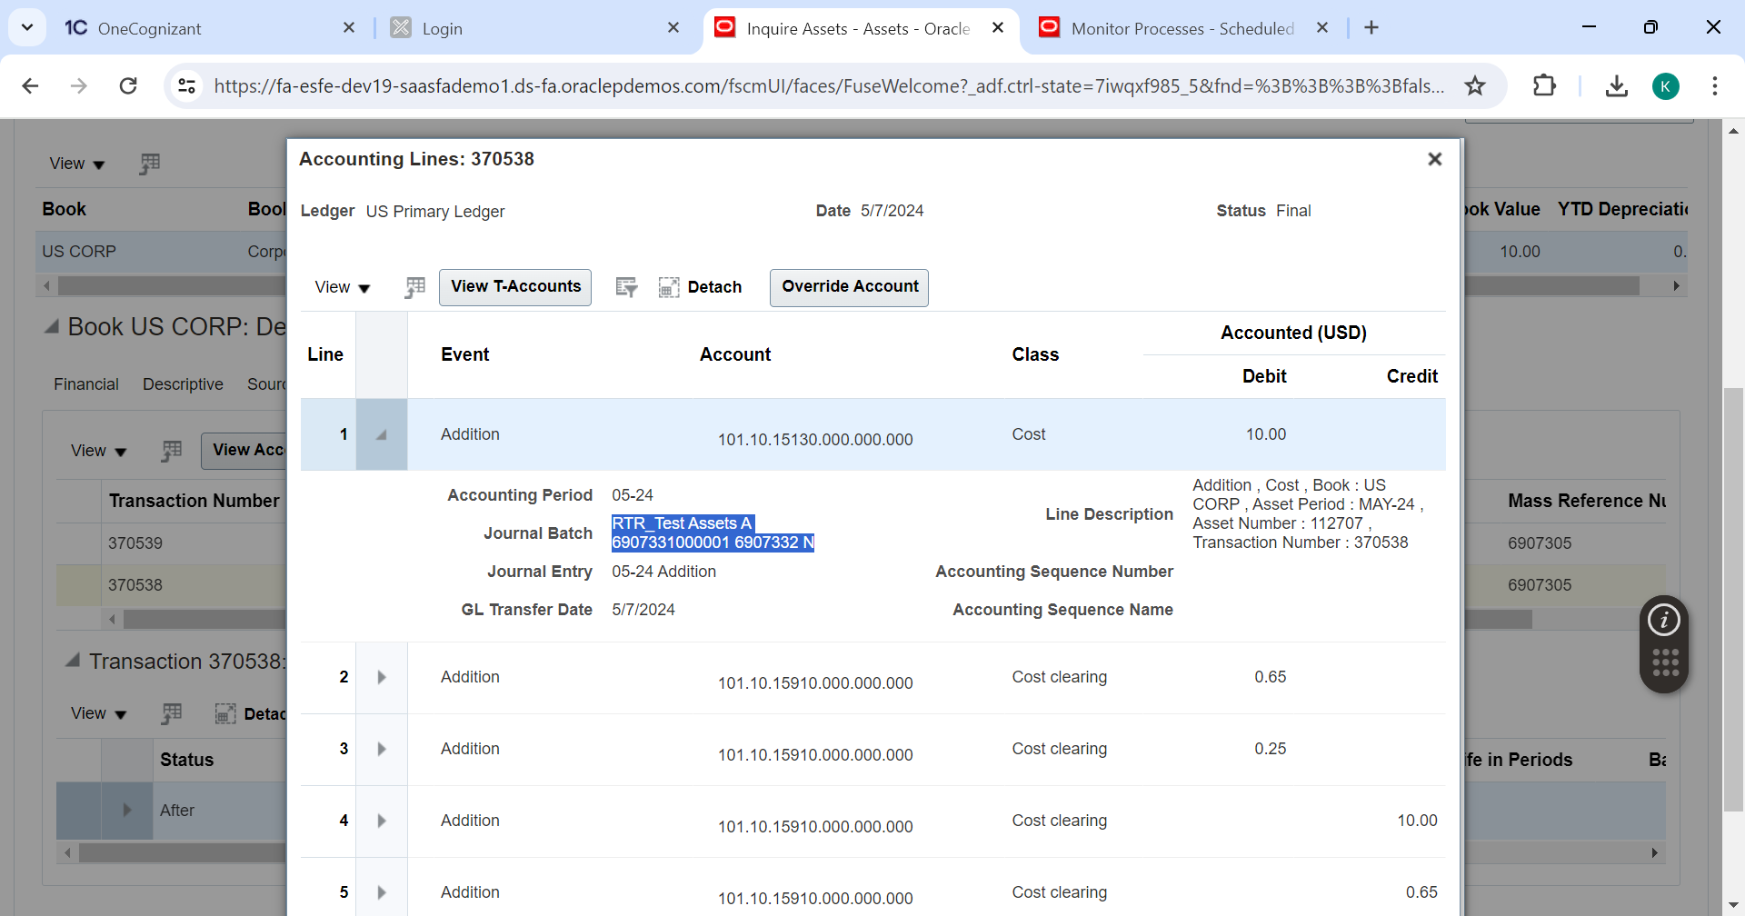

**Note down the journal batch and journal entry name.**

1. **Journal Entries GL**

**Navigate to 🡪General Accounting 🡪Journals**

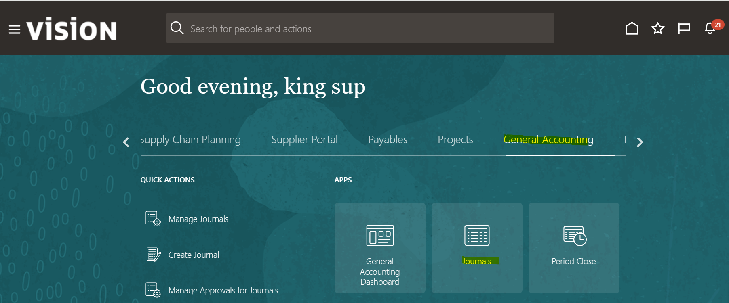

**Click on Manage Journals**

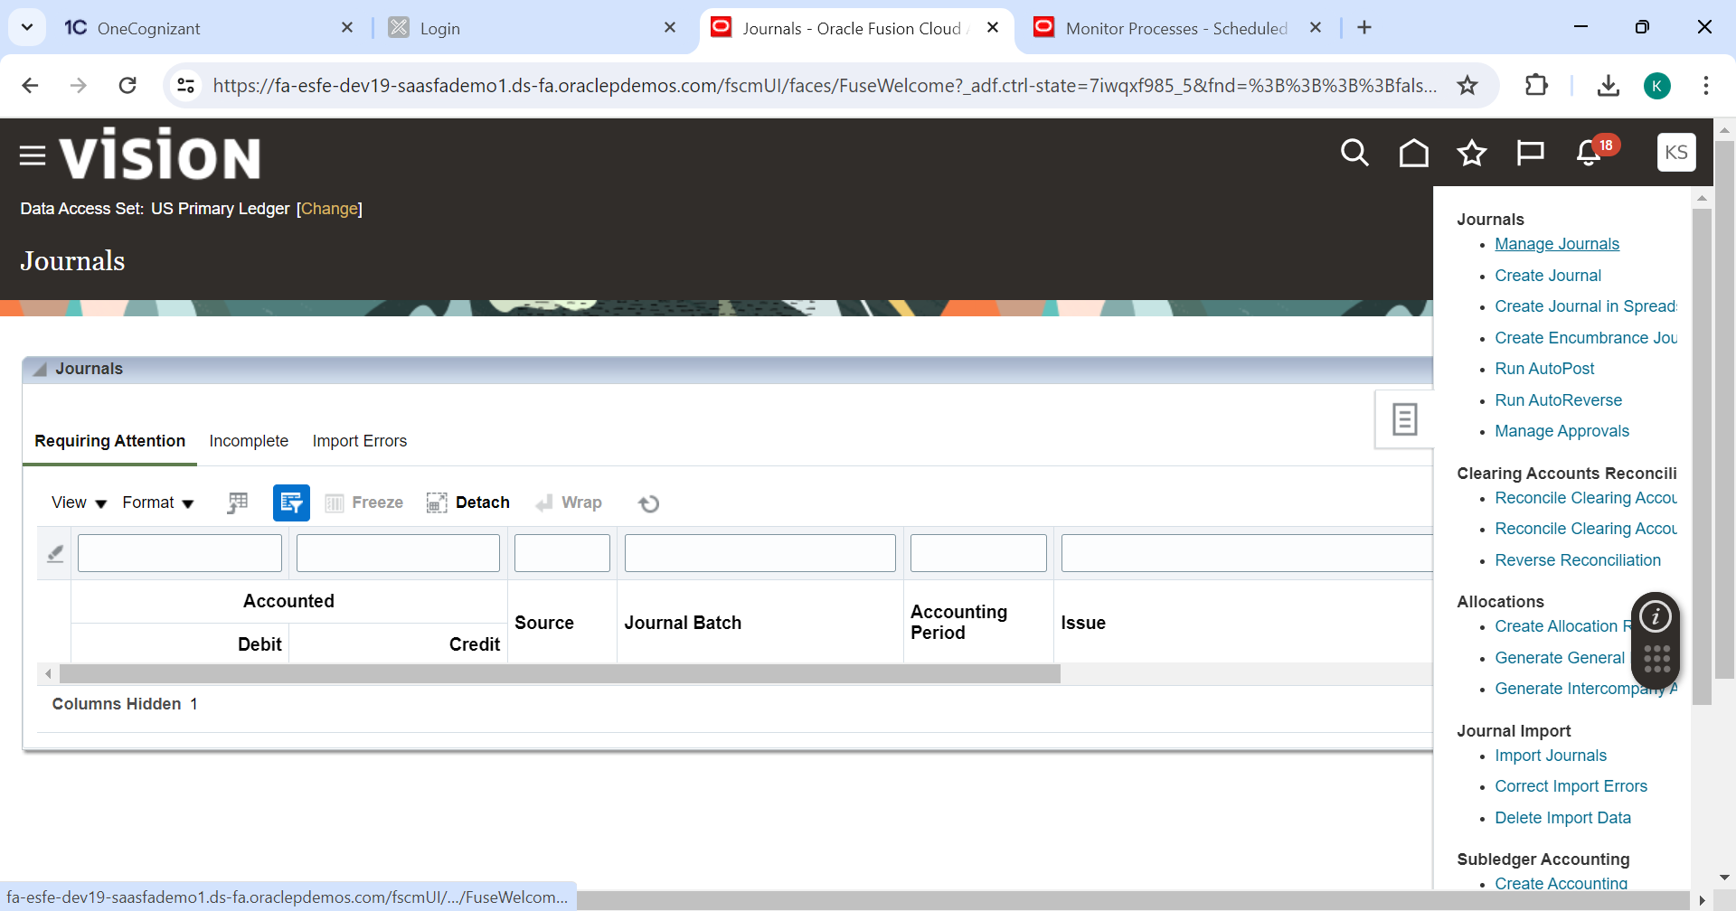

**Query the Journal batch name with current open period. Open the Journals**

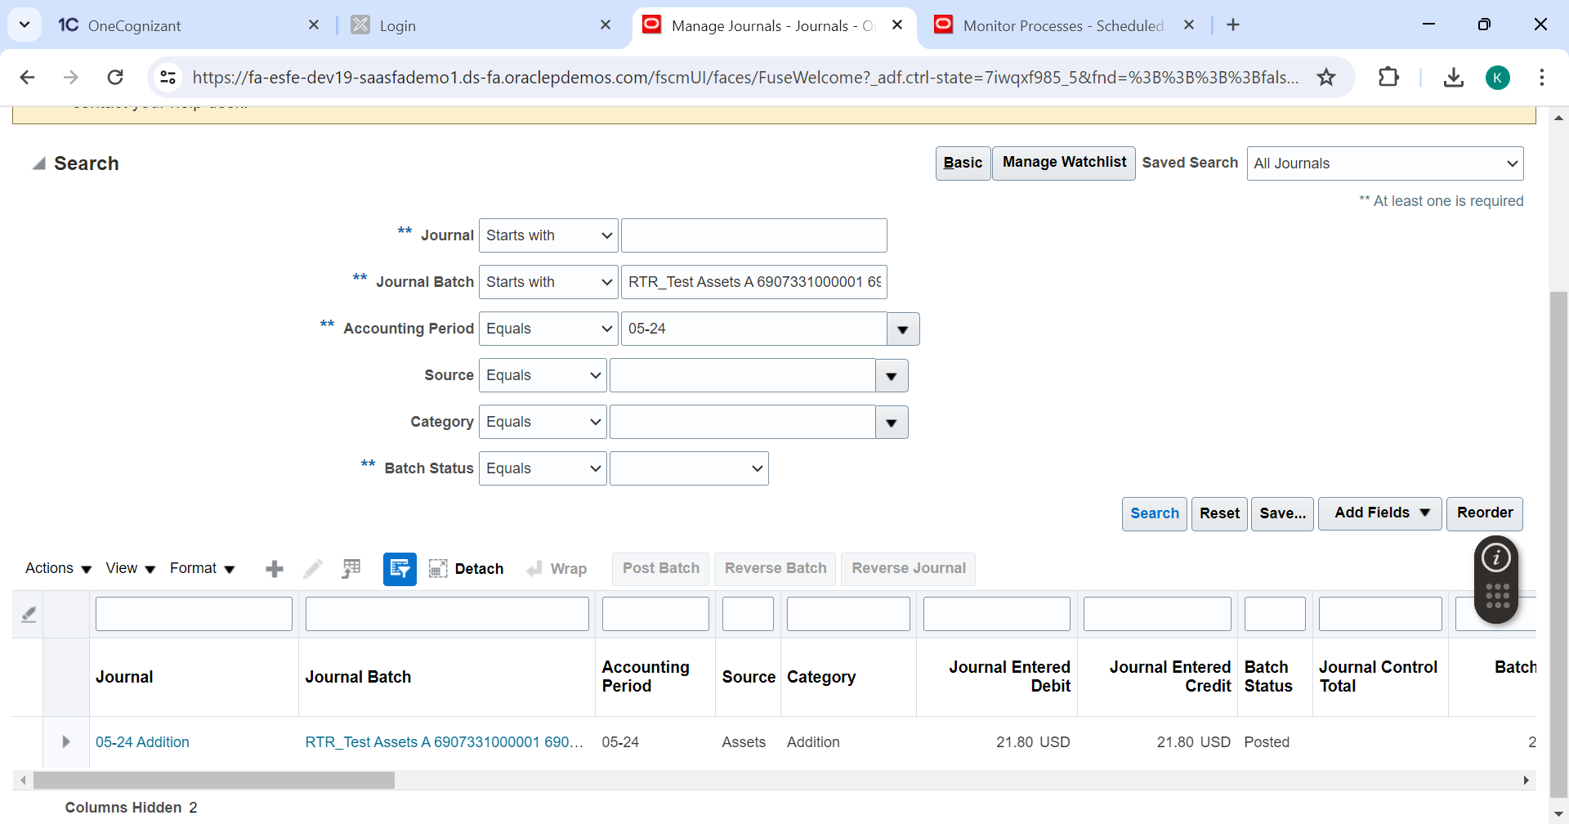

**Journal header details are fetched.**

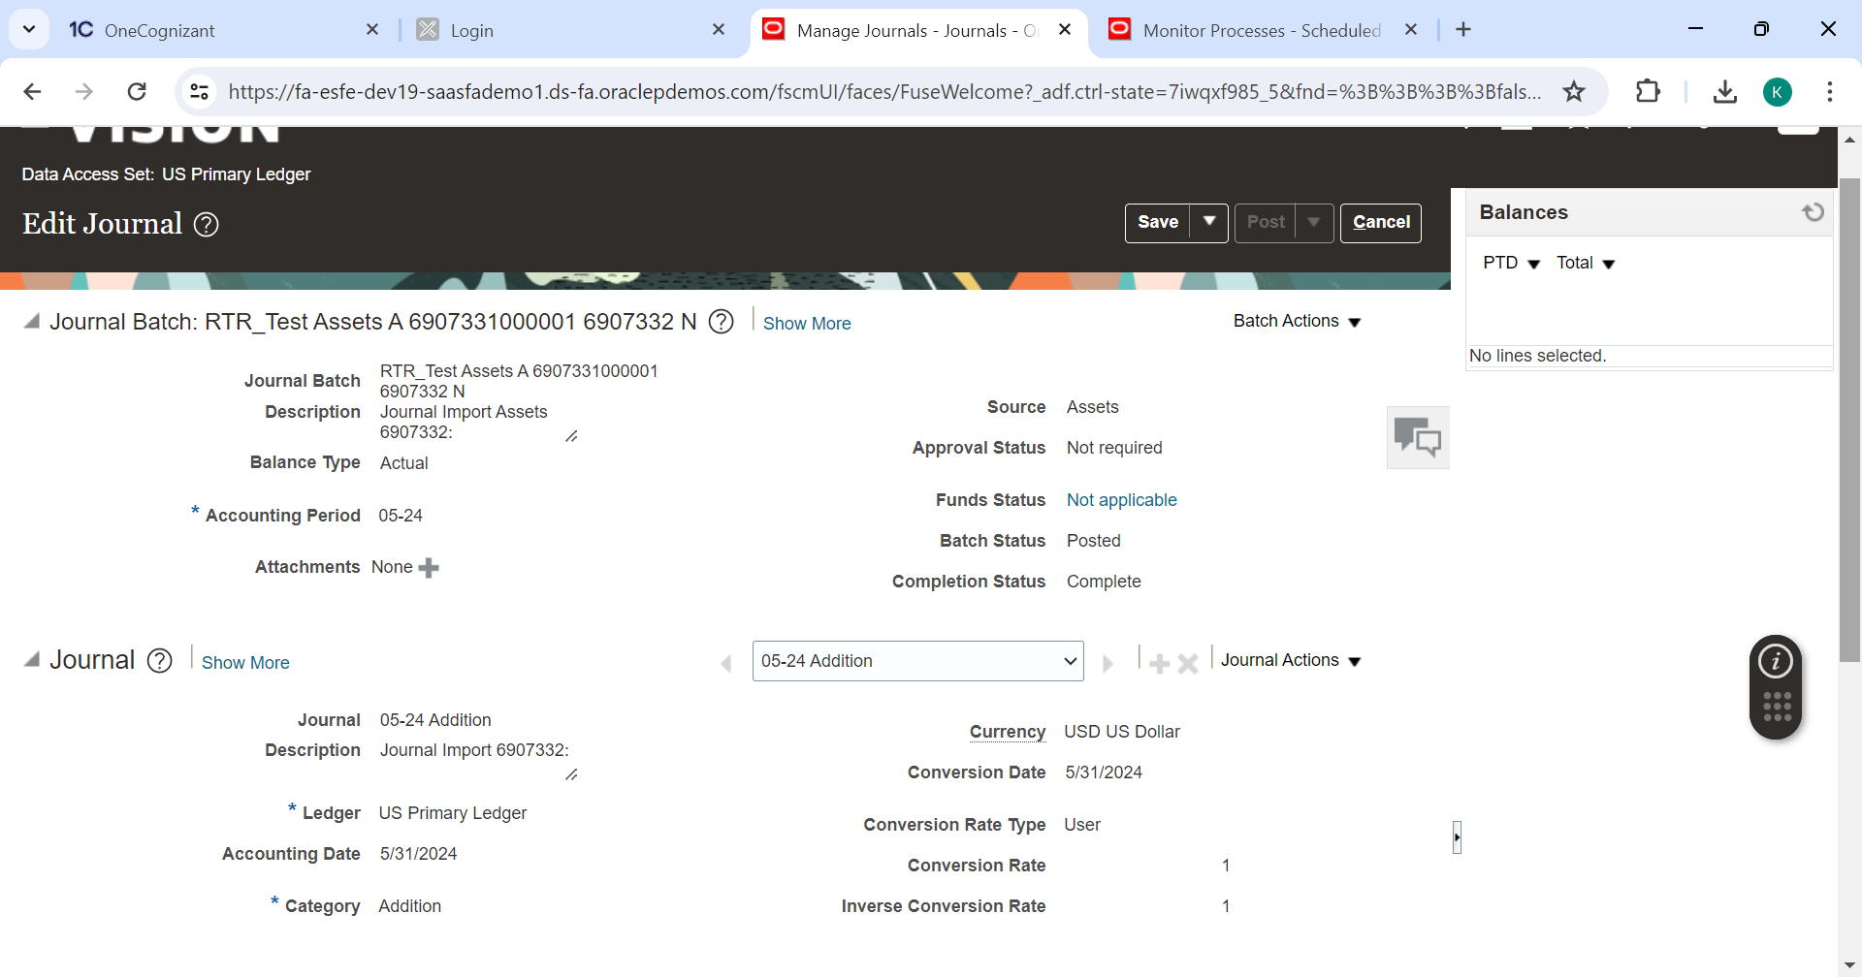

**Journal line details are fetched.**

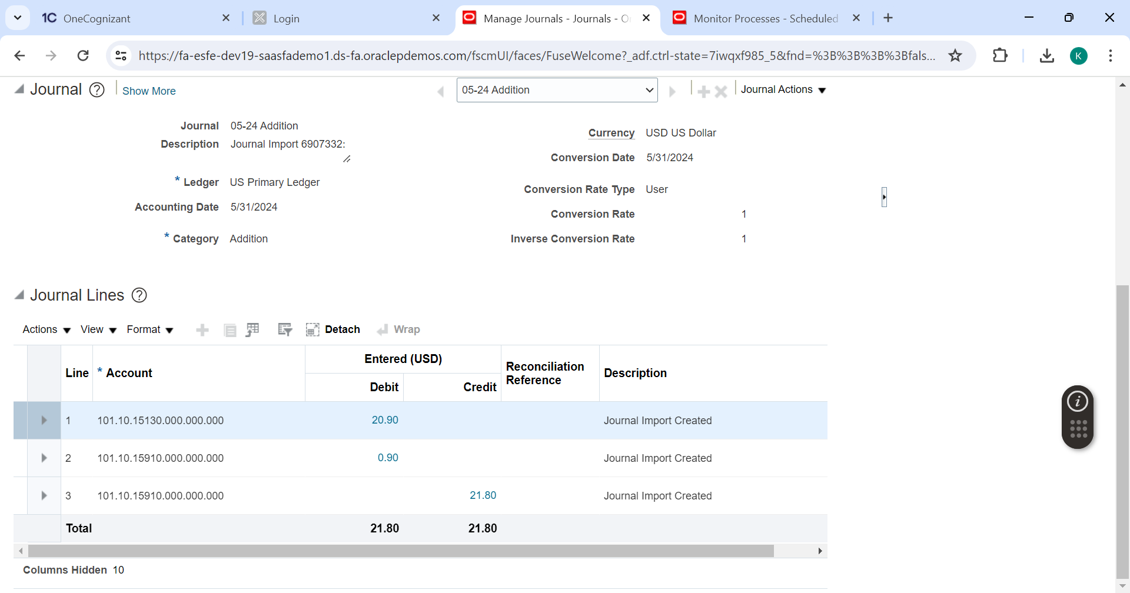

**Tools 🡪Scheduled Process**

**Submit process: Cost Clearing Reconciliation Report**

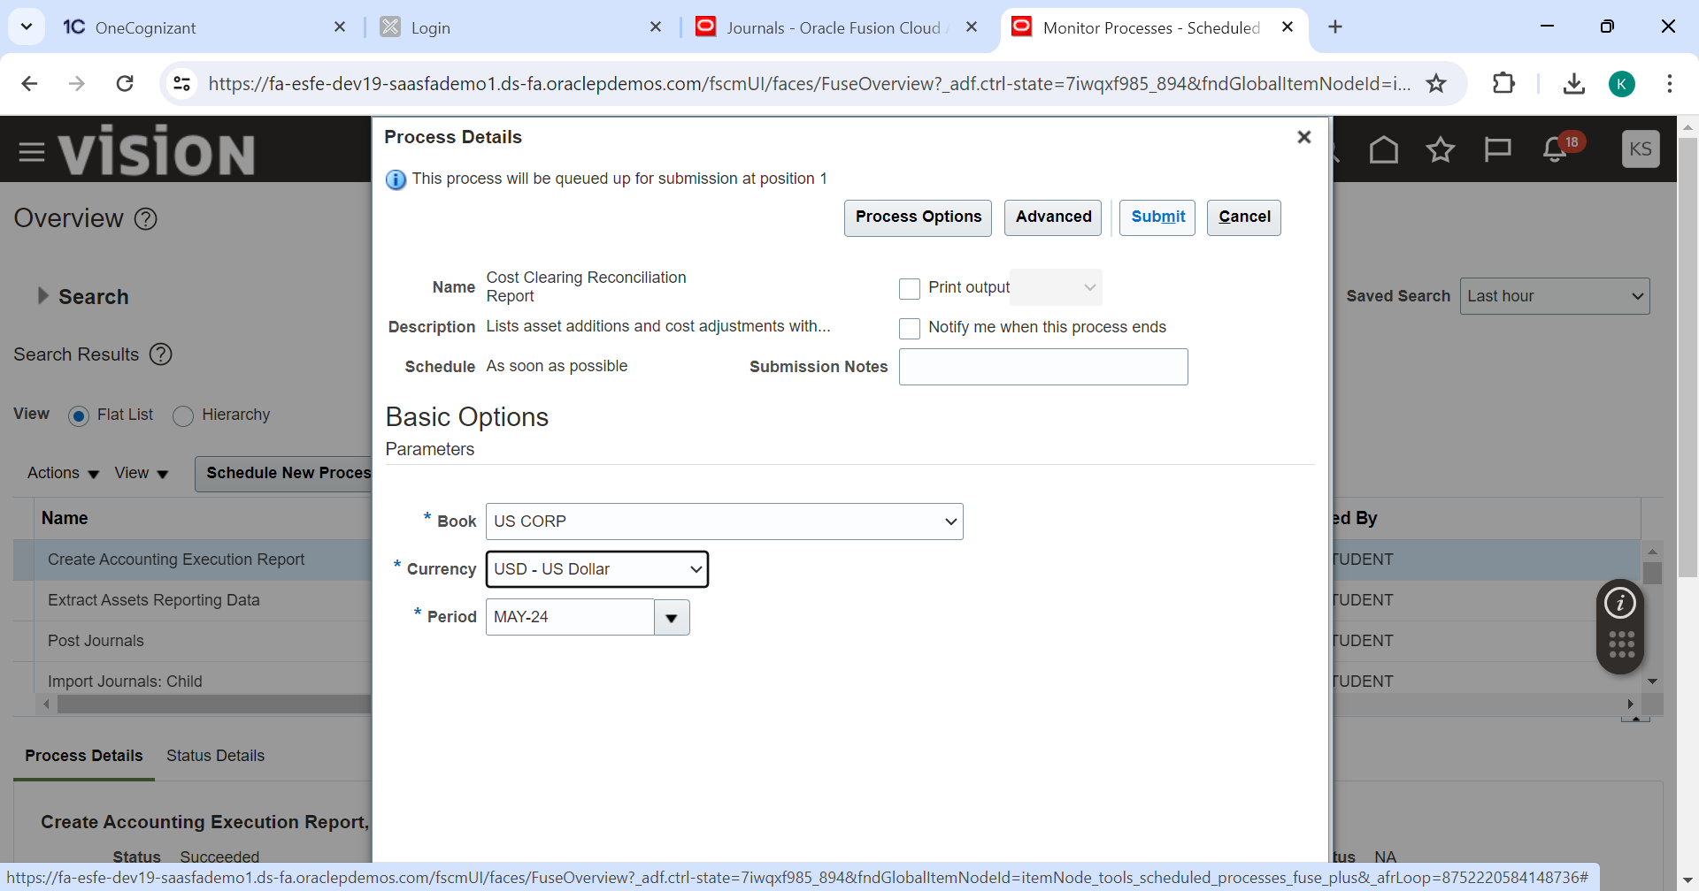

**Process submitted successfully.**

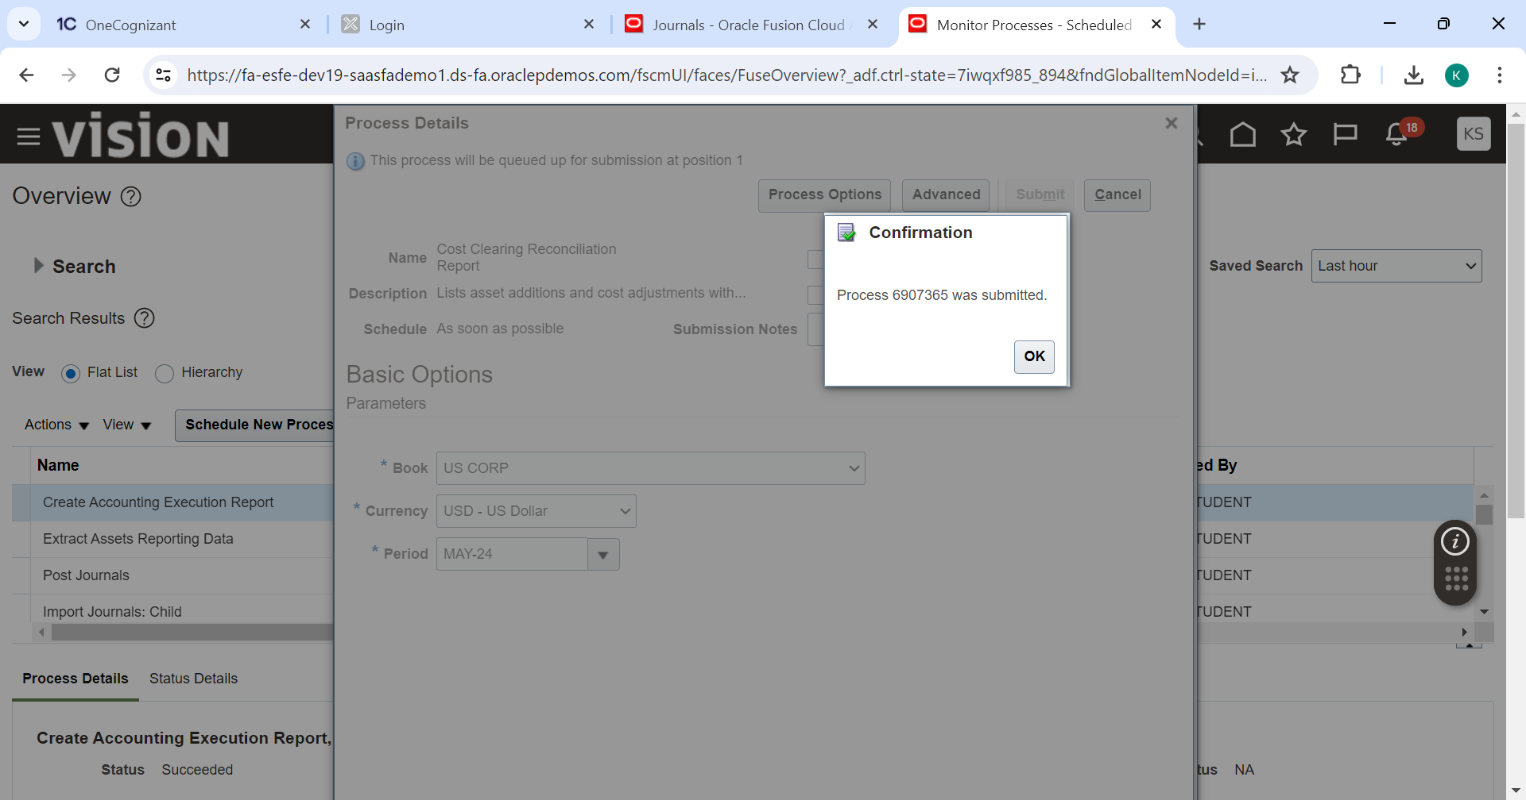

**Click on Cost clearing reconciliation report once successfully completed. And click on republish.**

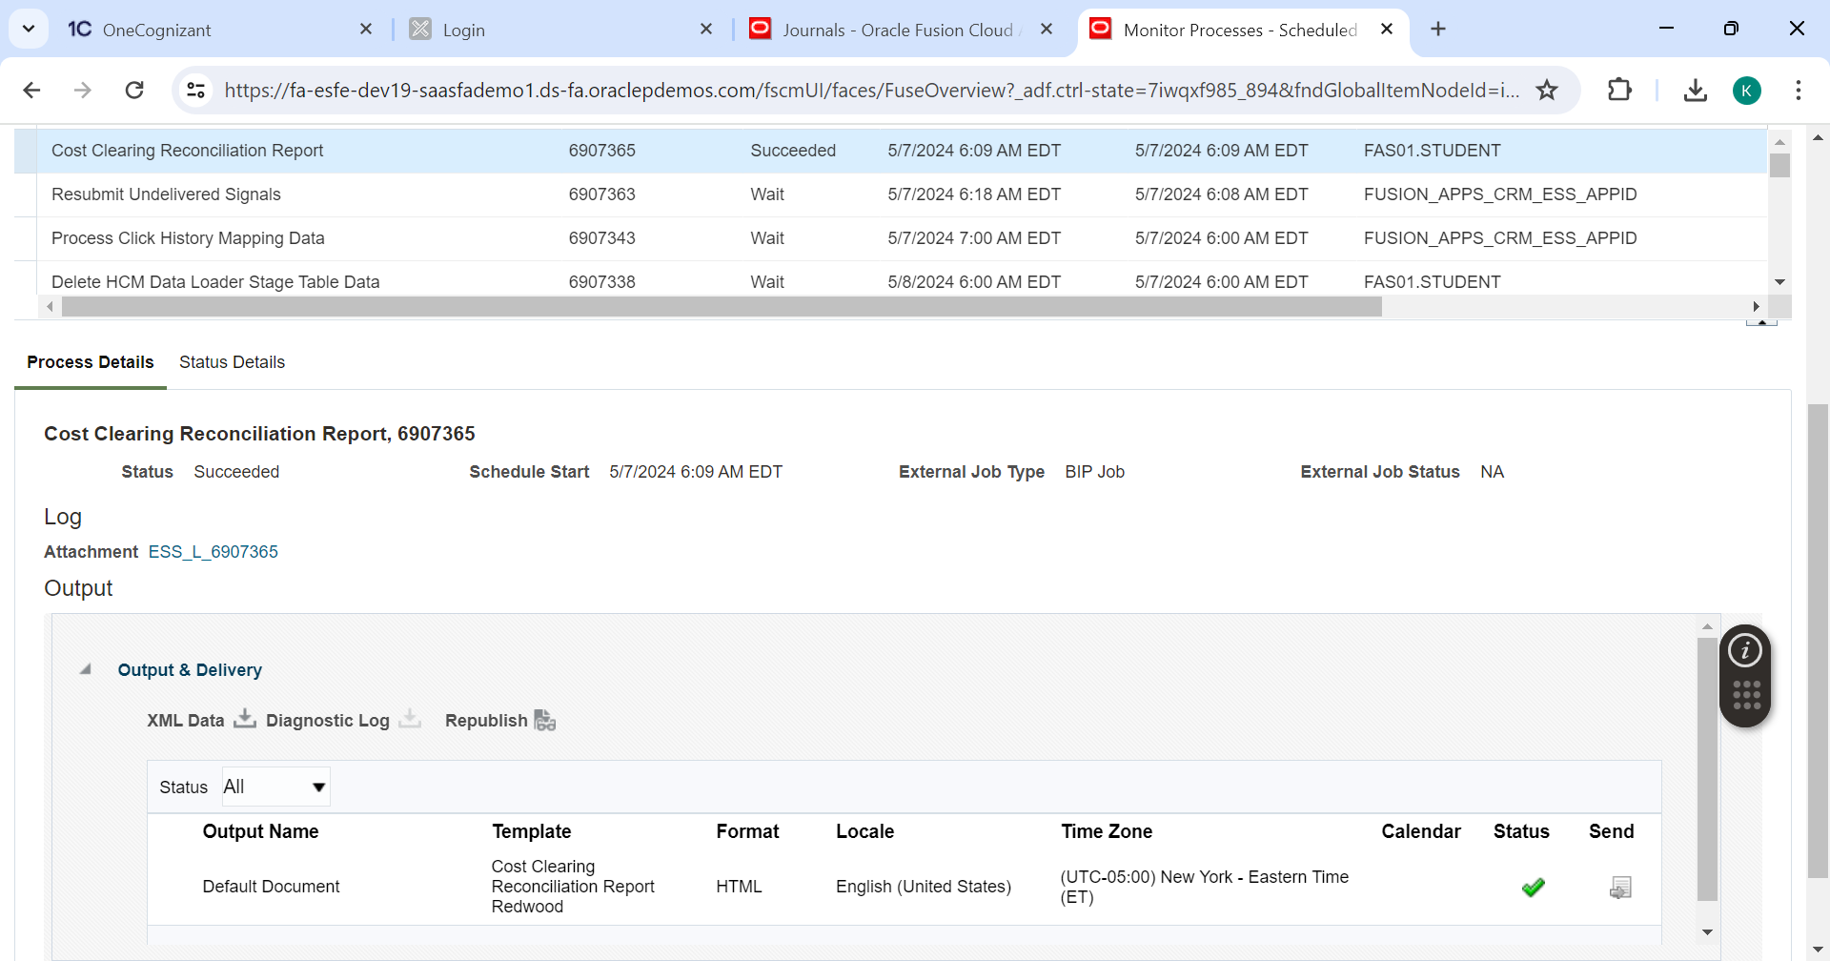

Click on republish and download the report

